Q1.
Scientists have used lasers to start a nuclear fusion reaction.
The scientists used the lasers to heat a small amount of an isotope of hydrogen.
(a) Describe what is meant by ‘isotopes’ of an element.
(2)
(b) Explain how nuclear fusion releases energy.
(3)
(c) The fusion reaction releases large amounts of energy.
The fusion reaction takes place in a reactor.
Explain why the walls of the reactor should be made from a material with a very high specific heat capacity.
(2)
(d) Nuclear fusion is safer than nuclear fission.
Nuclear fission can lead to an uncontrolled chain reaction.
Give one consequence of an uncontrolled chain reaction.
(1)
(Total 8 marks)
Q2.
The process of nuclear fission is used in nuclear power stations.
The figure below shows the process of nuclear fission.
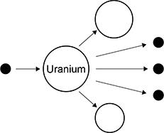
(a) Complete the sentences.
Choose answers from the box.

electrons | gamma rays | neutrons | nuclei | protons

In nuclear power stations, energy is released from uranium
______________________________ .
The uranium in above figure splits into two parts and releases three
______________________________ .
The process of nuclear fission releases electromagnetic radiation in the form of
______________________________.
(3)
Use the Physics Equations Sheet to answer parts (a) and (b).
(b) Write down the equation which links energy (E), power (P) and time (t).
(1)
(c) A nuclear power station has a power output of 500 MW.
Calculate the energy output in 3600 s.
Give your answer in J.
(3)
(d) Radioactive waste produced by nuclear power stations has a long half-life.
Suggest one precaution taken to reduce the hazard caused by radioactive waste from power stations.
(1)
(e) Nuclear power stations do not generate electricity every day of the year.
One nuclear power station generated electricity for 92% of a year.
one year = 365 days
Calculate the number of days during the year that the nuclear power station generated electricity.
(2)
(Total 10 marks)
Q3.
Scientists developed different models of the atom as new discoveries were made.
(a) Which particle in the atom was discovered first?
Tick (✓) one box.

Electron | 
Neutron
Proton
(1)
In an experiment that led to the nuclear model of the atom, alpha particles were directed at a sheet of gold foil.
The figure below shows the path of three alpha particles passing close to a gold nucleus.
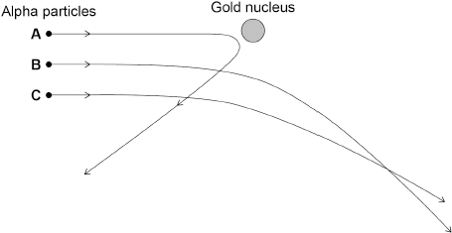
(b) An alpha particle has a radius of 1.7 femtometres.
The radius of a gold nucleus is 4.2 times larger than the radius of an alpha particle.
Calculate the radius of a gold nucleus in femtometres.
(2)
(c) Alpha particles are deflected by the gold nucleus.
What are the charges on an alpha particle and a gold nucleus?
Tick (✓) one box.

An alpha particle and a gold nucleus are both neutral.
An alpha particle and a gold nucleus are both positively charged.
An alpha particle is positively charged and a gold nucleus is neutral.
(1)
(d) Which statement describes the force between the alpha particle and the gold nucleus?
Tick (✓) one box.

A contact force
A force of attraction
A force of repulsion
There is no force
(1)
(e) Which alpha particle in the figure above experiences the largest force from the gold nucleus?
Tick (✓) one box.

A |  | B |  | C
(1)
The table below lists different models of the atom in alphabetical order.

Model
Bohr
Nuclear
Plum pudding
Tiny spheres that cannot be divided
(f) Which model in the table above was developed first?
(1)
(g) Which model in the table was developed last?
(1)
(Total 8 marks)
Q4.
Some isotopes emit nuclear radiation.
(a) Carbon-12 and carbon-14 are both isotopes of carbon.
Complete the sentences.
Choose answers from the box.

alpha particles | electrons | neutrons | protons
The nucleus of a carbon-12 atom and the nucleus of a carbon-14 atom have the
same number of _________________________.
The nucleus of a carbon-12 atom and the nucleus of a carbon-14 atom have a
different number of _________________________.
(2)
(b) Different radioactive isotopes have different half-lives.
What does ‘half-life’ mean?
Tick (✓) one box.

Half the time taken for all of the nuclei in a sample to decay.
The time taken for half the nuclei in a sample to decay.
The time taken for one nucleus to split in half.
(1)
(c) Table 1 shows the half-life of some different isotopes of carbon.

Table 1
Isotope | Half-life in seconds
Carbon-15 | 2.45
Carbon-16 | 0.75
Carbon-17 | 0.19
Carbon-18 | 0.09
Which isotope is the least stable?
Tick (✓) one box.

Carbon-15
Carbon-16
Carbon-17
Carbon-18
(1)
(d) Workers in nuclear power stations must be aware of nuclear irradiation and radioactive contamination.
Draw one line from each term to an example of the term.

Term |  | Example
 |  | Exposure to a beam of gamma rays
Radioactive contamination
 |  | Exposure to ultraviolet radiation from the Sun
 |  | Accidental transfer of plutonium onto a human body
Nuclear irradiation
 |  | Using a mobile phone
(2)
(e) Why are workers required to walk across a sticky floor before leaving the nuclear power station?
Tick (✓) one box.

To remove alpha particles from their shoes.
To remove gamma radiation from their shoes.
To remove radioactive dust from their shoes.
(1)
(f) The places where people work and live contribute to the nuclear radiation they are exposed to.
Table 2 shows the mean daily dose of radiation caused by two different jobs.
Table 2
Job | Mean daily dose in mSv
Aeroplane pilot | 0.072
Nuclear power station worker | 0.00050
Calculate the number of days a nuclear power station worker must work before receiving the same dose that an aeroplane pilot receives in one day.
(2)
(g) The process of nuclear fission takes place in nuclear power stations.
The process of nuclear fusion takes place in the Sun.
Draw one line from each process to its fuel.

Process |  | Fuel
 |  | Hydrogen
Nuclear fission
 |  | Iron
 |  | Lead
Nuclear fusion
 |  | Uranium
(2)
(Total 11 marks)
Q5.
Energy from the Sun is released by nuclear fusion.
(a) Complete the sentences.
Nuclear fusion is the joining together of ____________________.
During nuclear fusion the total mass of the particles _______________.
(2)
(b) Nuclear fusion of deuterium is difficult to achieve on Earth because of the high temperature needed.
Electricity is used to increase the temperature of 4.0 g of deuterium by 50 000 000 °C.
specific heat capacity of deuterium = 5200 J/kg °C
Calculate the energy needed to increase the temperature of the deuterium by 50 000 000 °C.
Use the Physics Equations Sheet.
(3)
(c) The idea of obtaining power from nuclear fusion was investigated using models.
The models were tested before starting to build the first commercial nuclear fusion power station.
Suggest two reasons why models were tested.
(2)
(d) Generating electricity using nuclear fusion will have fewer environmental effects than generating electricity using fossil fuels.
Explain one environmental effect of generating electricity using fossil fuels.
(2)
(Total 9 marks)
Q6.
Radioactive waste from nuclear power stations is a man-made source of background radiation.
(a) Which of the following is also a man-made source of background radiation?
Tick (✓) one box.

cosmic rays
radiotherapy
rocks
stars
(1)
(b) Nuclear power stations use the process of nuclear fission.
Complete the sentences to describe the process of nuclear fission.
Choose answers from the box.

 | a neutron |  | a proton |  | an electron
cosmic rays |  | energy |  | gamma rays |  | x-rays
An unstable nucleus absorbs _______________ and splits into two parts.
Two or three neutrons are released, as well as _______________
and _______________.
(3)
(c) Plutonium-239 is one type of radioactive waste from nuclear power stations.
The following nuclear equation represents the decay of plutonium-239 (Pu-239).
How does the nuclear equation show that alpha radiation is emitted when plutonium-239 decays?
Tick (✓) one box.

An alpha particle contains 92 protons.
An alpha particle has a mass number of 235.
An alpha particle is the same as a helium nucleus.
(1)
The graph below shows how the activity of a sample of plutonium-239 varies with time.
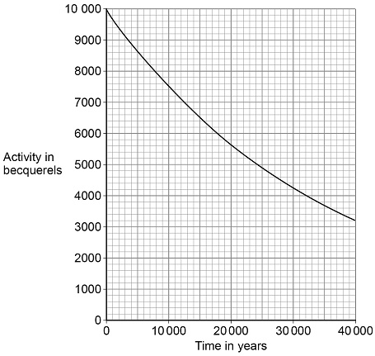
(d) How much time will it take for the activity of the sample of plutonium-239 to fall to half of its initial activity?
(1)
(e) What is the half-life of plutonium-239?
(1)
(f) The radioactive waste from a nuclear power station is buried underground.
People are warned to stay away from places where radioactive waste is buried.
Suggest one risk of going near the place where radioactive waste is buried.
(1)
(Total 8 marks)
Q7.
Radioactive waste from nuclear power stations is a man-made source of background radiation.
(a) Give one other man-made source of background radiation.
(1)
Nuclear power stations use the energy released by nuclear fission to generate electricity.
(b) Give the name of one nuclear fuel.
(1)
(c) Nuclear fission releases energy.
Describe the process of nuclear fission inside a nuclear reactor.
(4)
(d) A new type of power station is being developed that will generate electricity using nuclear fusion.
Explain how the process of nuclear fusion leads to the release of energy.
(2)
(e) Nuclear fusion power stations will produce radioactive waste. This waste will have a much shorter half-life than the radioactive waste from a nuclear fission power station.
Explain the advantage of the radioactive waste having a shorter half-life.
(2)
(Total 10 marks)
Q8.
Nuclear power can be used to generate electricity through nuclear fission.
Figure 1 shows the process of nuclear fission.
Figure 1
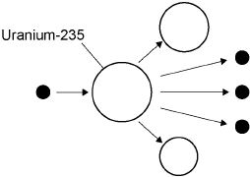
(a) Complete the sentences.
Choose answers from the box.

gamma rays | light rays | proton | neutron | nucleus | X-rays
During the process of nuclear fission, a uranium ___________________
absorbs a ___________________ .
Electromagnetic radiation is released in the form of ___________________ .
(3)
(b) The UK needs at least 25 000 000 kW of electrical power at any time.
A nuclear power station has an electrical power output of 2 400 000 kW
Calculate how many nuclear power stations are needed to provide 25 000 000 kW of electrical power.
(2)
(c) State two environmental issues caused by generating electricity using nuclear power stations.
(2)
(d) The UK currently generates a lot of electricity by burning natural gas. This process releases carbon dioxide into the atmosphere.
Figure 2 shows how the concentration of carbon dioxide in the atmosphere has changed over the past 115 years.
Figure 2
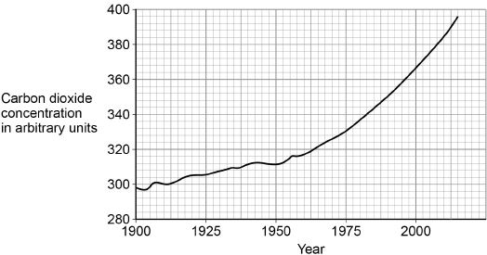
Figure 3 shows how the global temperature has changed over the past 115 years.
Figure 3
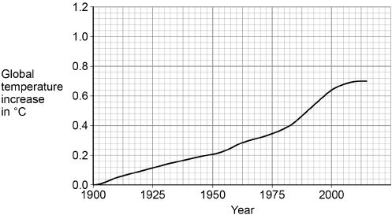
Give one similarity and one difference between the data in Figure 2 and Figure 3.
(2)
(Total 9 marks)
Q9.
Nuclear power stations generate electricity through nuclear fission. Electricity can also be generated by burning shale gas.
(a) Shale gas is natural gas trapped in rocks. Shale gas can be extracted by a process called fracking. There is some evidence that fracking causes minor earthquakes. Burning shale gas adds carbon dioxide to the atmosphere.
Describe the advantages of nuclear power compared with the use of shale gas to generate electricity.
(3)
(b) What is the name of one fuel used in nuclear power stations?
(1)
(c) Describe the process of nuclear fission.
(4)
(Total 8 marks)
Q10.
Nuclear fission and nuclear fusion are two processes that release energy.
(a) The following nuclear equation represents the fission of uranium-235 (U-235).
Chemical symbols:
• Ba = barium
• Kr = krypton
• = neutron
Describe the process of nuclear fission.
Use the information in the equation.
(4)
(b) Explain what happens in the process of nuclear fusion.
(3)
(c) Fission reactors are used in nuclear power stations.
Engineers are developing fusion reactors for use in power stations.
Fusion uses isotopes of hydrogen called deuterium and tritium.
• Deuterium is naturally occurring and can be easily extracted from seawater.
• Tritium can be produced from lithium. Lithium is also found in seawater.
The table shows the energy released from 1 kg of fusion fuel and from 1 kg of fission fuel.

Type of fuel | Energy released from 1 kg of fuel in joules
Fusion | 3.4 × 10¹⁴
Fission | 8.8 × 10¹³
Suggest two advantages of the fuel used in a fusion reactor compared with the fuel used in a fission reactor.
(2)
(Total 9 marks)
Q11.
(a) Uranium has two natural isotopes, uranium-235 and uranium-238.
Use the correct answer from the box to complete the sentence.

electrons | neutrons | protons
The nucleus of a uranium-238 atom has three more _____________ than the nucleus of a uranium-235 atom.
(1)
(b) Uranium-235 is used as a fuel inside a nuclear reactor.
Energy is released from nuclear fuels by the process of nuclear fission.
What is the energy released from nuclear fuels inside a nuclear reactor used for?
(1)
(c) Figure 1 shows the nucleus of an atom of uranium-235 (U-235) about to undergo nuclear fission.
Figure 1

(i) Before nuclear fission can happen the nucleus of a uranium atom has to absorb the particle labelled X.
What is particle X?
Tick (✔) one box.

an electron |  | a neutron |  | a proton
(1)
(ii) The process of nuclear fission, shown in Figure 2, causes the nucleus of the uranium-235 (U-235) atom to split apart and release two of the particles X.
Figure 2
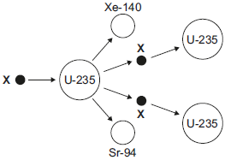
Complete Figure 2 to show how the particles X start a chain reaction.
(2)
(Total 5 marks)
Q12.
(a) Brown dwarf stars are thought to have been formed in the same way as other stars.
They are too small for nuclear fusion reactions to take place in them.
Brown dwarf stars emit infrared radiation but are not hot enough to emit visible light.
(i) Describe how a star is formed.
(2)
(ii) Describe the process of nuclear fusion.
(1)
(iii) Scientists predicted that brown dwarf stars existed before the first one was discovered in 1995.
Suggest one reason why scientists are now able to observe and identify brown dwarf stars.
(1)
(b) In the 18th century some scientists suggested a theory about how the planets formed in the Solar System. The theory was that after the Sun formed, there were cool discs of matter rotating around the Sun. These cool discs of matter formed the planets. The scientists thought this must have happened around other stars too.
(i) Thinking about this theory, what would the scientists have predicted to have been formed in other parts of the Universe?
(1)
(ii) Since the 1980s scientists studying young stars have shown the stars to be surrounded by cool discs of rotating matter.
What was the importance of these observations to the theory the scientists suggested in the 18th century?
(1)
(c) The Earth contains elements heavier than iron.
Why is the presence of elements heavier than iron in the Earth evidence that the Solar System was formed from material produced after a massive star exploded?
(1)
(Total 7 marks)
Q13.
Atoms are different sizes.
One of the heaviest naturally occurring stable elements is lead.
Two of its isotopes are lead-206 (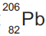) and lead-208 (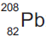).
(a) (i) What is meant by ‘isotopes’?
(2)
(ii) How many protons are in the nucleus of a atom?
(1)
(iii) How many neutrons are in the nucleus of a atom?
(1)
(b) A nucleus can be accelerated in a particle accelerator and directed at a large nucleus. This produces a heavy nucleus that will decay after a short time.
This is shown in Figure 1.
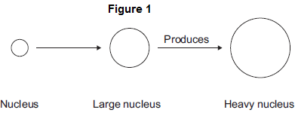
(i) In 1984, nuclei of iron (Fe) were directed at nuclei of lead (Pb). This produced nuclei of hassium (Hs).
Complete the equation for this reaction by writing numbers in the empty boxes.
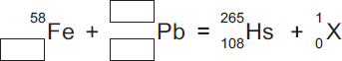
(3)
(ii) Use the correct answer from the box to complete the sentence.

an electron | a proton | a neutron
The particle X in part (b)(i) is _________________________________ .
(1)
(iii) After acceleration the iron nuclei travel at a steady speed of one-tenth of the speed of light.
The speed of light is 3.00 × 10⁸ m/s.
Calculate the time taken for the iron nuclei to travel a distance of 12 000 m.
(2)
(iv) Linear accelerators, in which particles are accelerated in a straight line, are not used for these experiments. Circular particle accelerators are used.
Suggest why.
(3)
(c) Hassium-265 (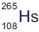) decays by alpha emission with a half-life of 0.002 seconds.
(i) What is meant by ‘half-life’?
Tick () two boxes.

Tick ()
The average time for the number of nuclei to halve
The time for count rate to be equal to background count
The time for background count to halve
The time for count rate to halve
(2)
(ii) Complete the equation for the decay of Hs-265 by writing numbers in the empty boxes.
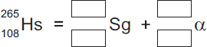
(2)
(d) The table below shows how the atomic radius of some atoms varies with atomic number.

Atomic  number | Atomic radius in  picometres (pm)
15 | 100
35 | 115
50 | 130
70 | 150
95 | 170
1 pm = 10^{–12} m
(i) On Figure 2, use the data from the table above to plot a graph of atomic radius against atomic number and draw a line of best fit.
Two points have been plotted for you.
Figure 2
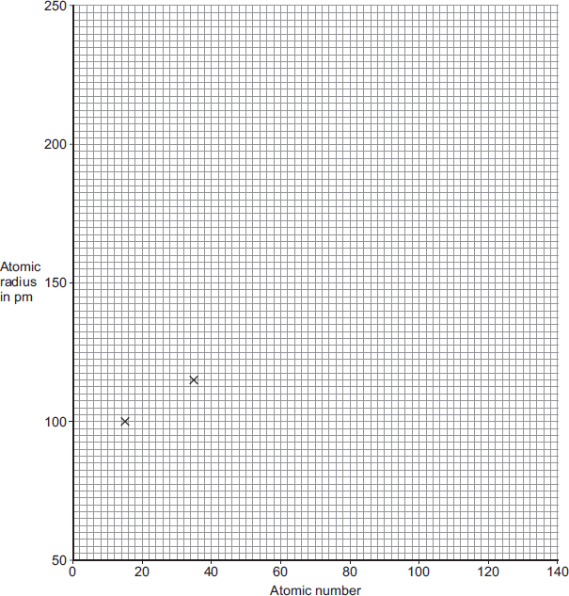
(2)
(ii) Scientists believe that the element with atomic number 126 can be produced and that it will be stable.
Use your graph in Figure 2 to predict the atomic radius of an atom with atomic number 126.
(1)
(Total 20 marks)
Q14.
The equation below shows the process by which two atomic nuclei join to form a different nucleus.
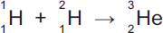
(a) Where does the process shown by the equation above happen naturally?
Tick () one box.

Inside the Earth | 
Inside a nuclear power station
Inside the Sun
(1)
(b) Use the correct answer from the box to complete the sentence.

fission | force | fusion
The process of joining two atomic nuclei to form a different nucleus is called
nuclear _________________________ .
(1)
(c) What is released during this process?
Draw a ring around the correct answer.

charge | energy | force
(1)
(Total 3 marks)
Q15.
Many countries use nuclear power stations to generate electricity.
Nuclear power stations use the process of nuclear fission to release energy.
(a) (i) What is nuclear fission?
(1)
(ii) Plutonium-239 is one substance used as a fuel in a nuclear reactor. For nuclear fission to happen, the nucleus must absorb a particle.
What type of particle must be absorbed?
(1)
(b) Nuclear fusion also releases energy.
Nuclear fusion happens at very high temperatures. A high temperature is needed to overcome the repulsion force between the nuclei.
(i) Why is there a repulsion force between the nuclei of atoms?
(1)
(ii) Where does nuclear fusion happen naturally?
(1)
(c) In 1991, scientists produced the first controlled release of energy from an experimental nuclear fusion reactor. This was achieved by fusing the hydrogen isotopes, deuterium and tritium.
Deuterium is naturally occurring and can easily be extracted from seawater. Tritium can be produced from lithium. Lithium is also found in seawater.
The table gives the energy released from 1 kg of fusion fuel and from 1 kg of fission fuel.

Type of fuel | Energy released from  1 kg of fuel in joules
Fusion fuel | 3.4 × 10¹⁴
Fission fuel | 8.8 × 10¹³
(i) Suggest two advantages of the fuel used in a fusion reactor compared with plutonium and the other substances used as fuel in a fission reactor.
(2)
(ii) Some scientists think that by the year 2050 a nuclear fusion power station capable of generating electricity on a large scale will have been developed.
Suggest one important consequence of developing nuclear fusion power stations to generate electricity.
(1)
(d) Tritium is radioactive.
After 36 years, only 10 g of tritium remains from an original sample of 80 g.
Calculate the half-life of tritium.
Show clearly how you work out your answer.
(2)
(Total 9 marks)
Q16.
Stars go through a life cycle.
Some stars will finish their life cycle as a black dwarf and other stars as a black hole.
(a) The table below gives the mass, relative to the Sun, of three stars, J, K and L.

Star | Mass of the star  relative to the Sun
J | 0.5
K | 14.5
L | 20.0
Which one of the stars, J, K or L, will become a black dwarf?
Give a reason for your answer.
(2)
(b) Scientists can take the measurements needed to calculate the mass of many stars.
Scientists cannot calculate the mass of the star Betelgeuse.
They estimate that the star has a mass between 8 and 20 times the mass of the Sun.
(i) Betelgeuse is in the red super giant stage of its life cycle.
What will happen to Betelgeuse at the end of the red super giant stage?
(1)
(ii) Suggest one reason why scientists can only estimate and not calculate the mass of Betelgeuse.
(1)
(iii) In the future, it may become possible for scientists to calculate the mass of Betelgeuse.
Suggest one reason why.
(1)
(c) Describe what happens to a star, after the main sequence period, for the star to eventually become a black dwarf.
(5)
(Total 10 marks)
Q17.
(a) There are many isotopes of the element molybdenum (Mo).
What do the nuclei of different molybdenum isotopes have in common?
(1)
(b) The isotope molybdenum-99 is produced inside some nuclear power stations from the nuclear fission of uranium-235.
(i) What happens during the process of nuclear fission?
(1)
(ii) Inside which part of a nuclear power station would molybdenum be produced?
(1)
(c) When the nucleus of a molybdenum-99 atom decays, it emits radiation and changes into a nucleus of technetium-99.
Mo Tc + Radiation
What type of radiation is emitted by molybdenum-99?
Give a reason for your answer.
(2)
(d) Technetium-99 has a short half-life and emits gamma radiation.
What is meant by the term ‘half-life’?
(1)
(e) Technetium-99 is used by doctors as a medical tracer. In hospitals it is produced inside a technetium generator by the decay of molybdenum-99 nuclei.
(i) The figure below shows how the number of nuclei in a sample of molybdenum-99 changes with time as the nuclei decay.
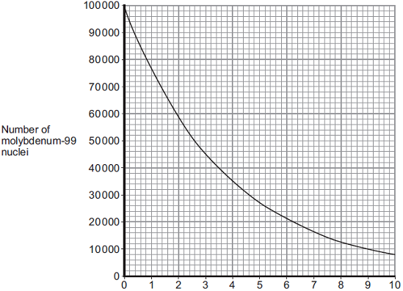
Time in days
A technetium generator will continue to produce sufficient technetium-99 until 80% of the original molybdenum nuclei have decayed.
After how many days will a source of molybdenum-99 inside a technetium-99 generator need replacing?
Show clearly your calculation and how you use the graph to obtain your answer.
(2)
(ii) Medical tracers are injected into a patient’s body; this involves some risk to the patient’s health.
Explain the risk to the patient of using a radioactive substance as a medical tracer.
(2)
(iii) Even though there may be a risk, doctors frequently use radioactive substances for medical diagnosis and treatments.
Suggest why.
(1)
(Total 11 marks)
Q18.
Nuclear fission and nuclear fusion are two processes that release energy.
(a) (i) Use the correct answer from the box to complete each sentence.

Geiger counter | nuclear reactor | star
Nuclear fission takes place within a ____________________________ .
Nuclear fusion takes place within a _____________________________ .
(2)
(ii) State one way in which the process of nuclear fusion differs from the process of nuclear fission.
(1)
(b) The following nuclear equation represents the fission of uranium-235 (U-235).
Chemical symbols:
Ba - barium
Kr - krypton
(i) Use the information in the equation to describe the process of nuclear fission.
(4)
(ii) An isotope of barium is Ba-139.
Ba-139 decays by beta decay to lanthanum-139 (La-139).
Complete the nuclear equation that represents the decay of Ba-139 to La-139.

(3)
(Total 10 marks)
Q19.
Nuclear power stations use the energy released from nuclear fuels to generate electricity.
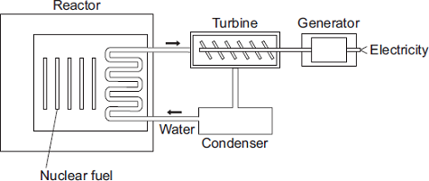
(a) Which substance do the majority of nuclear reactors use as fuel?
Draw a ring around your answer.

plutonium-239 | thorium-232 | uranium-235
(1)
(b) Energy is released from nuclear fuels by the process of nuclear fission.
Describe what happens to the nucleus of an atom during nuclear fission.
(2)
(c) Use words from the box to complete each sentence.

condenser | gas | generator | reactor | steam | turbine
The energy released from the nuclear fuel is used to heat water. The water turns
into ___________________ and this is used to drive a ___________________ .
This turns a ________________________ to produce electricity.
(3)
(Total 6 marks)
Q20.
(a) Nuclear power stations generate about 14% of the world’s electricity.
(i) Uranium-235 is used as a fuel in some nuclear reactors.
Name one other substance used as a fuel in some nuclear reactors.
(1)
(ii) Energy is released from nuclear fuels by the process of nuclear fission.
This energy is used to generate electricity.
Describe how this energy is used to generate electricity.
Do not explain the nuclear fission process.
(3)
(b) The diagram shows the nuclear fission process for an atom of uranium-235.
Complete the diagram to show how the fission process starts a chain reaction.
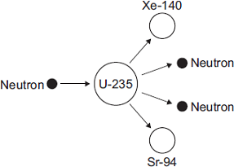
(2)
(c) The diagram shows the cross-section through a nuclear reactor.
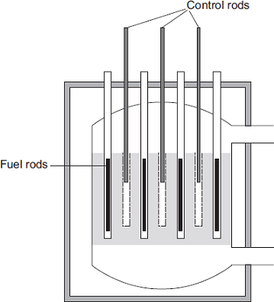
The control rods, made from boron, are used to control the chain reaction. Boron atoms absorb neutrons without undergoing nuclear fission.
Why does lowering the control rods reduce the amount of energy released each second from the nuclear fuel?
(2)
(Total 8 marks)
Q21.
Stars go through a life cycle. About 90 % of all stars are in the ‘main sequence’ period of the life cycle.
(a) Stars are stable during the ‘main sequence’ period of the life cycle.
Why?
(1)
(b) The table gives an estimated time for the number of years that three stars, X, Y and Z, will be in the ‘main sequence’ period of their life cycle.

Star | Relative mass of the star compared to the Sun | Estimated ‘main sequence’ period in millions of years
X | 0.1 | 4 000 000
Y | 1.0 | 9 000
Z | 40.0 | 200
(i) This data suggests that there is a pattern linking the mass of a star and the number of years the star is in the ‘main sequence’ period of its life cycle.
What is the pattern suggested by the data?
(1)
(ii) Scientists cannot give the exact number of years a star will be in the ‘main sequence’ period.
Suggest why.
(1)
(iii) Nuclear fusion is the process by which energy is released in stars.
Which one of the following can be concluded from the data in the table?
Draw a ring around the correct answer in the box to complete the sentence.

 | faster than
The rate of nuclear fusion in a large star is | the same as | in a small star.
 | slower than
Explain the reason for your answer.
(3)
(c) In this question you will be assessed on using good English, organising information clearly and using specialist terms where appropriate.
Describe what happens to a star much bigger than the Sun, once the star reaches the end of the ‘main sequence’ period of its life cycle.
Your answer should include the names of the stages the star passes through.
(6)
(Total 12 marks)
Q22.
Read this statement from a website.

Immediately after the ‘big bang’, at the start of the Universe, there were only atoms of the element hydrogen (H).
Now there are over one hundred elements.
Scientists think that all the elements on Earth are also present throughout the Universe.
(a) Explain how atoms of the element (He) are formed in a star.
(2)
(b) Explain how atoms of very heavy elements, such as gold (Au), were formed.
(2)
(c) Scientists have only examined a tiny fraction of the Universe.
What is the basis for scientists thinking that the elements found on Earth are present throughout the Universe?
(1)
(Total 5 marks)
Q23.
(a) Nuclear fuels and the wind are two of the energy sources used to generate electricity in the UK.
Explain the advantages of using energy from nuclear fuels to generate electricity rather than using energy from the wind.
Include in your answer a brief description of the process used to generate electricity from nuclear fuels.
(4)
(b) In the UK, most electricity is generated in power stations that emit carbon dioxide into the atmosphere. The impact of these power stations on the environment could be reduced by the increased use of 'carbon capture' technology.
Describe how 'carbon capture' would prevent the build-up of carbon dioxide in the atmosphere.
(2)
(Total 6 marks)
Q24.
(a) Nuclear fission is used in nuclear power stations to generate electricity. Nuclear fusion happens naturally in stars.
(i) Explain briefly the difference between nuclear fission and nuclear fusion.
(2)
(ii) What is released during both nuclear fission and nuclear fusion?
(1)
(b) Plutonium-239 is used as a fuel in some nuclear reactors.
(i) Name another substance used as a fuel in some nuclear reactors.
(1)
(ii) There are many isotopes of plutonium.
What do the nuclei of different plutonium isotopes have in common?
(1)
(Total 5 marks)
Q25.
(a) The diagram shows the lifecycle of a star.
(i) Use words or phrases from the box to complete the sentences contained in the diagram.

black dwarf | black hole | protostar | red giant

 | Gas and dust are pulled together to form a  ___________________________  The star gives out energy as a main sequence star.  The star expands forming a __________________  The star shrinks to form a white dwarf.  The star fades away as a ___________________
(3)
(ii) The table compares the approximate size of three stars with the size of the Sun.

Star | Size
Alpha Centauri A | the same as the Sun
Betelgeuse | 1120 times bigger than the Sun
Cephei | 1520 times bigger than the Sun
Which one of these three stars has the lifecycle shown in part (a)(i)?
Give a reason for your answer.
(2)
(b) Which one of the following describes the process by which energy is given out in stars?
Tick () one box.
Atomic nuclei inside the star join together. | 
Atomic nuclei inside the star split apart.
Gases inside the star burn.
(1)
(Total 6 marks)
Q26.
(a) As part of its life cycle, a star changes from being a protostar to a main sequence star.
Explain the difference between a protostar and a main sequence star.
(2)
(b) The early Universe contained only atoms of hydrogen. The Universe now contains atoms of over one hundred different elements.
Explain how the different elements now contained in the Universe were formed.
(3)
(Total 5 marks)
Q27.
The names of three different processes are given in List A.
Where these processes happen is given in List B.
Draw a line to link each process in List A to where the process happens in List B.
Draw only three lines.

List A |  | List B
Process |  | Where it happens
 |  | in a star
fusion
 |  | in a nuclear reactor
chain reaction
 |  | in a smoke precipitator
alpha decay
 |  | in the nucleus of an atom
(Total 3 marks)
Q28.
The flowchart shows a simple version of the life cycle of a star that is much more massive than the Sun.
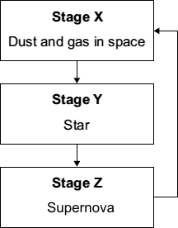
(a) What causes the change from Stage X to Stage Y?
(1)
(b) For most of its time in Stage Y, the star is stable.
Explain why the star remains stable.
(2)
(c) (i) Explain how a star is able to produce energy in Stage Y.
(2)
(ii) Why is a star in Stage Y able to give out energy for millions of years?
(1)
(d) What happens to the elements produced in a supernova?
(1)
(Total 7 marks)
Q29.
When the nucleus of a radium-225 atom decays, it changes into a nucleus of actinium-225.

What type of radiation is emitted by radium-225?
Draw a ring around your answer.

alpha | beta | gamma
Explain the reason for your answer.
(Total 3 marks)
Q30.
This passage is from a web page.

Our nearest star, the Sun
The pie chart shows the proportions of chemical elements in the Sun.
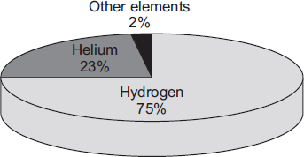
Most of the Sun’s helium has been produced from the Sun’s hydrogen by
the process of nuclear fusion. This process also produces vast quantities
of energy. The process takes place in the core of the Sun at a temperature
of about 15 million °C and has been going on for about 4.5 billion years.
During this period of time, the Sun has remained stable and scientists think
that it will remain stable for several billion years into the future.
(a) Explain why the Sun remains stable.
(3)
(b) A scientific opinion is expressed on this web page.
Identify this opinion and suggest how scientists could justify it.
(2)
(Total 5 marks)
Q31.
The process of nuclear fusion results in the release of energy.
(a) (i) Describe the process of nuclear fusion.
(2)
(ii) Where does nuclear fusion happen naturally?
(1)
(b) For many years, scientists have tried to produce a controlled nuclear fusion reaction that lasts long enough to be useful. However, the experimental fusion reactors use more energy than they produce.
(i) From the information given, suggest one reason why nuclear fusion reactors are not used to produce energy in a nuclear power station.
(1)
(ii) Suggest one reason why scientists continue to try to develop a practical nuclear fusion reactor.
(1)
(Total 5 marks)
Q32.
(a) Our star, the Sun, is stable.
Explain what the conditions need to be for a star to remain stable.
(2)
(b) Shortly after the ‘big bang’, hydrogen was the only element in the Universe.
Explain how the other elements came to be formed.
(3)
(Total 5 marks)
Q33.
(a) Uranium atoms do not always have the same number of neutrons.
What are atoms of the same element that have different numbers of neutrons called?
(1)
(b) By emitting an alpha particle, an atom of uranium-235 decays into an atom of thorium.
An alpha particle, which is the same as a helium nucleus, is represented by the symbol .
The decay can be represented by the equation below.
Complete the equation by writing the correct number in each of the two boxes.
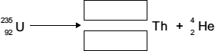
(2)
(c) The diagram shows an atom of uranium-235 being split into several pieces.
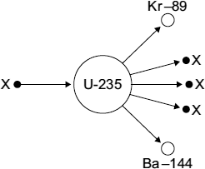
(i) Name the process shown in the diagram.
(1)
(ii) Name the particles labelled X.
(1)
(d) Uranium-235 is used as a fuel in some nuclear reactors.
Name another substance used as a fuel in some nuclear reactors.
(1)
(Total 6 marks)
Q34.
Every star goes through a ‘life cycle’.
(a) Describe how a star forms.
(2)
(b) During a long period of its life, a star remains in a stable state.
Explain why a star remains stable.
(2)
(c) Some stars are much more massive than the Sun.
Describe what will happen to a star, originally much more massive than the Sun, after it reaches its red giant stage.
(2)
(Total 6 marks)
Q35.
Four different processes are described in List A. The names of these processes are given in List B.
Draw a line to link each description in List A to its correct name in List B.
Draw only four lines.
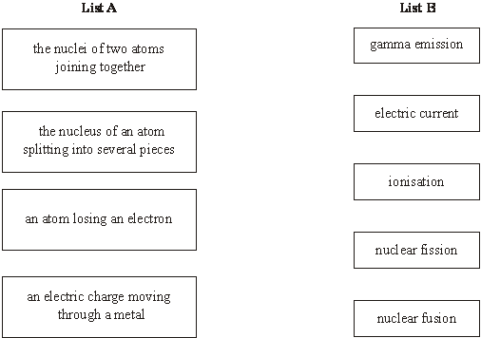
(Total 4 marks)
Q36.
Read this statement from a website.

Immediately after the ‘big bang’, at the start of the Universe, there were only atoms of the element hydrogen (H).
Now the Universe contains atoms of over one hundred elements.
(a) Explain how atoms of the element helium (He) are formed in a star.
(2)
(b) Explain how atoms of very heavy elements, such as gold (Au), were formed.
(2)
(c) Explain how, and when, atoms of different elements may be distributed throughout the Universe.
(2)
(Total 6 marks)
Q37.
The table gives information about the three types of particle that make up an atom.

Particle | Relative mass | Relative charge
Proton |  | +1
Neutron | 1
Electron | very small | –1
(a) Complete the table by adding the two missing values.
(2)
(b) Use the information in the table to explain why an atom has no overall electrical charge.
(2)
(c) Uranium has two natural isotopes, uranium-235 and uranium-238.
Uranium-235 is used as a fuel inside a nuclear reactor.
Inside the reactor, atoms of uranium-235 are split and energy is released.
(i) How is the structure of an atom of uranium-235 different from the structure of an atom of uranium-238?
(1)
(ii) The nucleus of a uranium-235 atom must absorb a particle before the atom is able to split.
What type of particle is absorbed?
(1)
(iii) The nucleus of an atom splits into smaller parts in a reactor.
What name is given to this process?
(1)
(Total 7 marks)
Q38.
This passage is from a science magazine.

A star forms when enough dust and gas are pulled together.
Masses smaller than a star may also be formed when dust and gas are pulled together.
(a) What is the force which pulls the dust and gas together?
(1)
(b) Complete the sentences.
(i) The smaller masses may be attracted by the star and become
_____________________________________________________________ .
(1)
(ii) Our nearest star, the Sun, is stable because the gravitational forces
and the radiation pressure are _____________________________________ .
(1)
(iii) The Sun is one of billions of stars in the galaxy called the
_____________________________________________________________ .
(1)
(Total 4 marks)
Q39.
The diagram shows part of the life cycle of a star which is much bigger than the Sun.
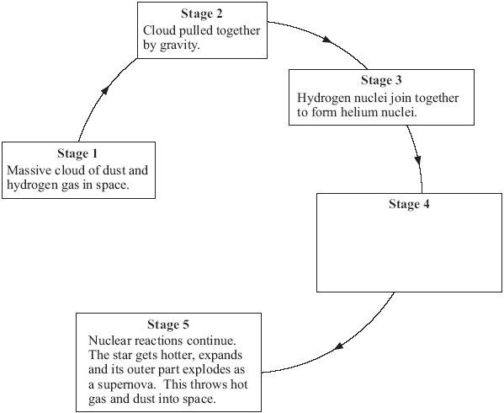
(a) (i) What is the relationship between the masses of the dust and gas in the cloud in Stage 2 and the force of gravity between them?
(1)
(ii) What is the relationship between the distance apart of the dust and gas in the cloud in Stage 2 and the force of gravity between them?
(1)
(b) In Stage 3 the star remains stable for millions of years.
Explain why.
(2)
(c) What happens in Stage 4?
(2)
(Total 6 marks)
Q40.
(a) The diagram shows what can happen when the nucleus of a uranium atom absorbs a neutron.
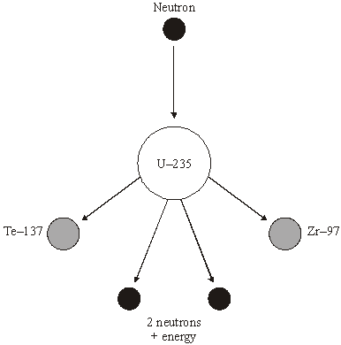
(i) What name is given to the process shown in the diagram?
(1)
(ii) Explain how this process could lead to a chain reaction.
You may wish to add further detail to the diagram to help your answer.
(2)
(iii) How does the mass number of an atom change when its nucleus absorbs a neutron?
(1)
(b) Uranium-235 is used as a fuel in some nuclear reactors.
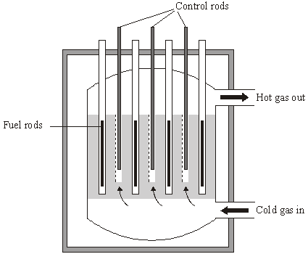
Source: adapted from ‘Physics Matters’, by Nick England. Published by
Hodder and Stoughton, 1989. Reproduced by permission of Hodder and Stoughton Ltd.
The reactor contains control rods used to absorb neutrons.
Suggest what happens when the control rods are lowered into the reactor.
(2)
(Total 6 marks)
Q41.
Read the passage.

In the SolarSystem, the inner planets, such as the Earth, contain elements which are eavierthan the elements hydrogen and helium.
Our star,the Sun, is a medium sized star. If a star is much more massive than the Sunit will eventually swell into a red giant, start to contract, continue tocontract and finally explode.
(a) What is the explosion called?
(1)
(b) Explain why scientists believe that the Solar System was formed from the material produced when earlier stars exploded.
(3)
(Total 4 marks)

Q42.
(a) Complete the two spaces in the sentence.
Stars form when enough ________________ and gas from ________________ are
pulled together by gravitational attraction.
(2)
(b) How are stars able to give out energy for millions of years?
Put a tick () next to the answer.

By atoms joining together | 
By atoms splitting apart
By burning gases
(1)
(c) There are many billions of stars in our galaxy. Our Sun is one of these stars. What is the name of our galaxy?
(1)
(d)
Why was the Universe created?
We cannot expect scientists to answer this question. What is the reason for this?
Put a tick () next to the reason.

It will take too long to collect the scientific evidence.
The answer depends on beliefs and opinions, not scientific evidence.
There is not enough scientific evidence.
(1)
(Total 5 marks)
Q43.
The statement in the box is from an article in a science magazine.

Scientists think that all the elements on Earth are also present throughout the Universe.
(a) (i) Name the process by which these elements were formed.
(1)
(ii) Where did the elements form?
(1)
(iii) What caused these elements to be distributed throughout the Universe?
(1)
(b) Scientists have only examined a tiny fraction of the Universe. What is the basis for the statement in the science magazine?
(1)
(Total 4 marks)
Q44.
To gain full marks in this question you should write your ideas in good English. Put them into a sensible order and use the correct scientific words.
Explain briefly how stars like the Sun are thought to have been formed.
(Total 2 marks)
Q45.
(a) Nuclear power stations use the energy released by nuclear fission to generate electricity.
(i) Explain what is meant by nuclear fission.
(2)
(ii) How does nuclear fission lead to a chain reaction?
You may give your answer as a labelled diagram.

(1)
(b) Although nuclear fuels are relatively cheap the total cost of generating electricity using nuclear fuels is expensive. Why?
(1)
(c) The table compares the energy released from 1 kg of coal and 1 kg of uranium.

Coal | 29 MJ | 1 MJ = 1 000 000 joules
Uranium | 580 000 MJ
State one benefit to the environment of using a concentrated fuel like uranium to generate electricity rather than using the energy from coal.
(1)
(Total 5 marks)
Q46.
(a) Explain how stars produce energy.
(2)
(b) What evidence is there to suggest that the Sun was formed from the material produced when an earlier star exploded?
(1)
(c) It is thought that gases from the massive star Cygnus X-1 are spiralling into a black hole.
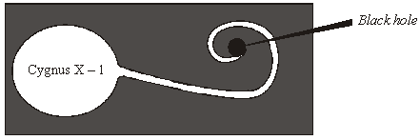
(i) Explain what is meant by the term black hole.
(2)
(ii) What is produced as the gases from a star spiral into a black hole?
(1)
(Total 6 marks)
Q47.
(a) Uranium-234 (²³⁴U) is a radioactive element. The graph shows the number of protons and neutrons in the nuclei of the elements formed when uranium-234 decays.
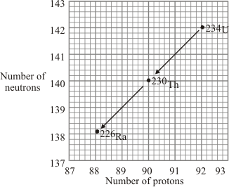
(i) How does the graph show that uranium-234 (²³⁴U) and thorium-230 (²³⁰Th) emit alpha particles?
(1)
(ii) What makes uranium and thorium different elements?
(1)
(iii) Radioactive decay may also produce gamma radiation.
Why does the emission of gamma radiation not cause a new element to be formed?
(1)
(b) The graph shows how the thickness of different materials needed to absorb 90% of the gamma radiation emitted by a source depends on the energy of the radiation. The energy of the gamma radiation is given in units called electron-volts.
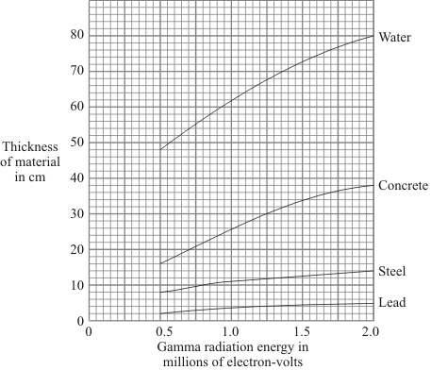
(i) Which of the materials shown is least effective at absorbing gamma radiation?
Use the information in the graph to give a reason for your answer.
(1)
(ii) For gamma radiation of energy 1.5 million electron-volts, how many times more effective is steel than water at absorbing the radiation? Show clearly how you obtain your answer.
(2)
(c) Scientists in the early twentieth century thought that atoms were made up of electrons scattered inside a ball of positive charge. This was called the ‘plum-pudding’ model of the atom.
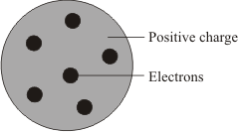
Plum pudding model
Rutherford and Marsden did an experiment, in which a beam of alpha particles was aimed at a thin sheet of gold.
Explain how the results of this experiment led to a new model of the atom.
You may include one or more diagrams in your answer.
(3)
(Total 9 marks)
Q48.
(a) Most of the Sun is hydrogen. Inside the core of the sun, hydrogen is being converted to helium. What name is given to this process and why is the process so important?
(2)
(b) Describe what will happen to the Sun as the core runs out of hydrogen.
(3)
(Total 5 marks)
Q49.
The first commercial nuclear power station in the world was built at Calder Hall in Cumbria.
(a) The fuel used at the Calder Hall power station is uranium. Natural uranium consists mainly of two isotopes: uranium-235 and uranium-238. The nucleus of a uranium-235 atom is different to that of a uranium-238 atom.
(i) Where is the nucleus in an atom?
(1)
(ii) Name the two types of particle found in the nucleus.
(2)
(iii) How is the nucleus of a uranium-238 atom different to the nucleus of a uranium-235 atom?
(2)
(b) In the nuclear reactor fission of uranium atoms takes place in reactions such as the one shown below.
+ + + 3()
The nuclear reactions are carefully controlled in the power station so that a chain reaction takes place.
Explain, as fully as you can:
(i) how fission of uranium atoms takes place in a nuclear reactor;
(ii) how this leads to a chain reaction;
(iii) why it can be used to generate electricity.
(4)
(Total 9 marks)
Q50.
The first commercial nuclear power station in the world was built at Calder Hall in Cumbria.
The atoms produced by the fission of uranium are also radioactive. The used fuel is sent to a reprocessing plant where it can be safely treated.
(i) Calder Hall power station is next to the Sellafield reprocessing plant. Suggest an advantage of having the two plants close together.
(1)
(ii) One of the radioactive products is iodine-138. This has a half-life of 6 seconds.
A sample of radioactive material contains 2000 atoms of iodine-138.
How long will it take for the number of iodine-131 atoms to decrease to 125?
(3)
(Total 4 marks)
Q51.
Nuclear fusion in the Sun releases large amounts of energy.
(i) Explain what is meant by nuclear fusion.
(3)
(ii) Why is energy released by such nuclear fusion reactions?
(2)
(Total 5 marks)
Q52.
(a) The Sun is at the stable stage of its life.
Explain, in terms of the forces acting on the Sun, what this means.
(3)
(b) At the end of the stable stage of its life a star will change.
Describe and explain the changes that could take place.
(6)
(Total 9 marks)
Q53.
Our Sun is just one of many millions of stars in a galaxy called the Milky Way.
Our Sun is in the main stable period of a star’s lifetime. The massive force of gravity draws its matter together. This force is balanced by the very high temperatures, from the fusion of hydrogen atoms, which tend to make the Sun expand. Describe and explain what will happen to the Sun as the hydrogen is eventually used up.
(Total 3 marks)
Q54.
Studying stars gives scientists evidence about the evolution of the Universe.
(a) (i) In astronomy, what is meant by a black hole?
(2)
(ii) How is it possible to detect a black hole?
(2)
(b) The changes which happen in stars result in new elements being formed.
Nuclei of the heaviest elements are found in the Sun.
Describe how these nuclei are formed.
(2)
(Total 6 marks)
Q55.
One theory of the origin of the Universe was that billions of years ago all matter was in one place, then it exploded (‘big bang’).
Describe, in as much detail as you can, how our star (the Sun) formed from the time when there was just dust and gas (mostly hydrogen) up to now when it is in its main stable period.
To gain full marks in this question you should write your ideas in good English. Put them into a sensible order and use the correct scientific words.
(Total 5 marks)
Q56.
The Sun at the centre of our solar system is a star.
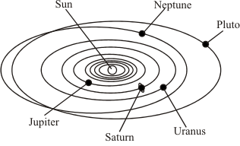
(a) The Sun contains nuclei of the heaviest elements. Atoms of these heaviest elements are also present in the planets of the solar system. What does this suggest about the material from which the solar system is formed?
(1)
(b) Stars form from gas (mostly hydrogen) and dust.
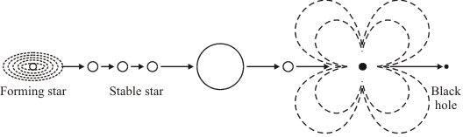
Describe, in as much detail as you can, what forces allow a stable star to exist and how the star may eventually form a black hole.
To gain full marks in this question you should write your ideas in good English. Put them into a sensible order and use the correct scientific words.
(6)
(Total 7 marks)
Q57.
The flowchart shows four stages thought to occur in the evolution of a star such as our Sun.
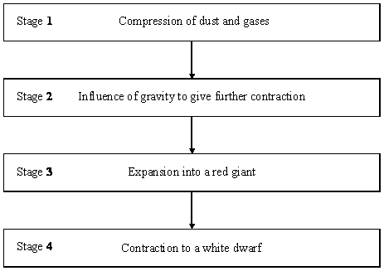
At a particular time a star might have reached one of these stages or be between stages or be at a further stage. What period in its evolution has our star, the Sun, reached?
(Total 1 mark)
Q58.
At the very high temperatures in the sun, hydrogen is converted into helium. It takes four hydrogen nuclei to produce one helium nucleus.
The table shows the relative masses of hydrogen and helium nuclei.
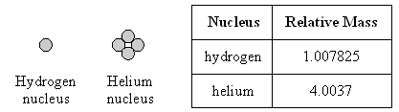
(a) Use these figures to calculate what happens to the mass of the sun as hydrogen is converted to helium.
(3)
(b) Use your answer to part (a) to explain how the sun has been able to radiate huge amounts of energy for billions of years.
(2)
(Total 5 marks)
Q59.
The energy radiated by a main sequence star like the Sun is released by a nuclear fusion reaction in its core.
Read the following information about this reaction then use it to answer the questions below.
• The net result of the nuclear fusion reaction is that four hydrogen nuclei produce one helium nucleus. There is a loss of mass of 0.7%.
• For nuclear fusion to occur nuclei must collide at very high speeds.
• The energy released during the reaction can be calculated as shown:
energy released [J] = loss of mass [kg] × (speed of light [m/s²])
(The speed of light is 3 × 10⁸ m/s)
(a) Calculate the energy released when 1g of hydrogen fuses to form helium.
(Show your working.)
(4)
(b) The table shows the lifetimes and surface temperatures of main sequence stars with different masses.

MASS OF STAR  [SUN = 1] | LIFETIME ON MAIN SEQUENCE  [MILLION OF YEARS] | SURFACE TEMPERATURE * [KELVIN]
0.5 | 200 000 | 4000
1 | 10 000 | 6000
3 | 500 | 11 000
15 | 15 | 30 000
[* The higher the surface temperature of a star, the higher the temperature and pressure in its core.]
(i) Describe the relationship between the lifetime of a main sequence star and its mass.
(2)
(ii) Suggest an explanation for this relationship.
(3)
(Total 9 marks)
Q60.
Describe, in as much detail as you can, the life history of a star like our Sun.
(Total 6 marks)
Mark schemes
Q1.
(a) (atoms of an element with) the same number of protons
ignore number of electrons
allow same atomic number
1
but a different number of neutrons
allow different mass number
1
(b) light(er) nuclei fuse
allow hydrogen nuclei fuse
ignore bonding / colliding
1
to form heavier nuclei / elements
allow to form helium nuclei
1
some of the mass (of the nuclei) is converted into energy (of radiation)
1
(c) (a large amount of energy transferred) causes a small temperature increase of the walls / material
1
(therefore) the walls of the reactor should not reach melting point
allow (therefore) the walls of the reactor should not melt
1
(d) any one from:
• a nuclear explosion
• a (nuclear) meltdown
• a nuclear bomb
allow atomic for nuclear
allow Chernobyl / Fukushima (disaster)
1
[8]
Q2.
(a) nuclei
1
neutrons
1
gamma rays
this order only
1
(b) energy = power × time
or
E = P × t
1
(c) P = 500 000 000 (W)
1
E = 500 000 000 × 3600
allow a correct substitution of an incorrectly / not converted value of P
1
E = 1 800 000 000 000 (J)
or
E = 1.8 × 10¹² (J)
allow an answer consistent with an incorrectly / not converted value of P
1
(d) any one from:
• bury the radioactive waste
• put the radioactive waste in cooling ponds
allow store it for (at least) one half-life
• transport the radioactive waste in secure vessels
• store the radioactive waste in metal containers
• cover the radioactive waste in concrete
ignore references to high / medium / low level waste
ignore label the waste as hazardous
1
(e)
number of days = 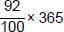
1
number of days = 335.8
allow answers of 335 and 336 days
allow an answer of 29.2 (days) for 1 mark
1
[10]
Q3.
(a) electron
1
(b) radius = 1.7 × 4.2
1
radius = 7.14 (femtometres)
allow 7.1 (femtometres)
1
(c) an alpha particle and a gold nucleus are both positively charged
1
(d) a force of repulsion
1
(e) A
1
(f) tiny spheres that can't be divided
1
(g) Bohr
1
[8]
Q4.
(a) protons
this order only
1
neutrons
1
(b) the time taken for half the nuclei in a sample to decay
1
(c) carbon-18
1
(d)
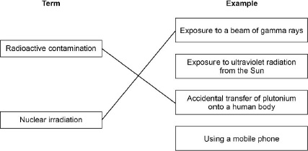
1 mark for each correct line
additional line from a box on the left negates the mark for that box
2
(e) to remove radioactive dust from their shoes
1
(f) 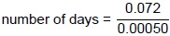
1
number of days = 144
1
(g)
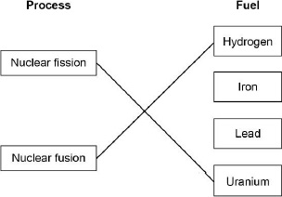
1 mark for each correct line
additional line from a box on the left negates the mark for that box
2
[11]
Q5.
(a) nuclei
do not accept atoms
1
decreases
1
(b) m = 0.004 (kg)
1
E = 0.004 × 5200 × 50 000 000
allow a correct substitution of an incorrectly/not converted value of m
1
E = 1.04 × 10⁹ (J)
or
E = 1 040 000 000 (J)
allow a correct calculation using an incorrectly/not converted value of m
1
(c) any two from:
• to make sure the fusion process is possible
• to develop an understanding of the process
• to make adaptations to the process
• to assess the efficiency of the process
• to make predictions
• assess safety risks
• to assess environmental impact
• set-up cost is lower (for small scale experiments)
2
(d) releases carbon dioxide
allow releases greenhouse gases
1
which causes global warming
allow which causes climate change
OR
releases particulates
which causes global dimming
or
which cause breathing problems
OR
releases sulfur dioxide
which cause acid rain
OR
releases nitrogen oxides
which cause breathing problems
or
which causes acid rain
1
[9]
Q6.
(a) radiotherapy
1
(b) a neutron
1
energy
energy and gamma rays can score in reverse order
1
gamma rays
1
(c) An alpha particle is the same as a helium nucleus.
1
(d) 24 000 (years)
allow an answer between 24 000 and 24 500 (years) inclusive
1
(e) 24 000 (years)
or
their (d)
1
(f) Any one from:
• irradiation
• cancer
• genetic damage
• mutations to DNA / genes
• radiation sickness / poisoning
1
[8]
Q7.
(a) Any one from:
• (medical) x-rays
allow CT scans
• radiotherapy
• nuclear weapons (testing)
allow nuclear fallout
• named nuclear disaster e.g. Chernobyl / Fukushima / Three Mile Island.
ignore radioactive / nuclear waste
1
(b) uranium / plutonium
ignore any number given
allow thorium
1
(c) neutron absorbed by a uranium nucleus
1
nucleus splits into two parts
allow an atom splits into two parts if 1st marking point doesn’t score
1
and (2/3) neutrons (are released)
1
and gamma rays (are emitted)
1
(d) lighter nuclei join to form heavier nuclei
allow specific examples
1
some of the mass (of the nuclei) is converted to energy (of radiation)
1
(e) activity decreases quickly
allow nuclei / waste will decay at a greater rate
ignore waste is radioactive for less time
1
risk of harm decreases quickly
allow burial site doesn’t need to be monitored for as long
or
doesn’t need to be buried underground for as long
or
may not need to be buried underground
1
[10]
Q8.
(a) nucleus
1
neutron
1
gamma rays
1
in this order only
(b) 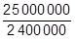
1
11
an answer of 10.4 with no working scores 1 mark
1
an answer of 11 scores 2 marks
(c) any two from:
• waste is radioactive
allow nuclear waste
• waste has a long half-life
allow waste remains dangerous for a long time
• waste is toxic
• waste needs to be buried
allow waste is difficult to dispose of
• risk of catastrophic accidents
allow named accident e.g. Fukushima, Chernobyl, Three Mile Island
• fuel is non-renewable
2
(d) similarity:
(carbon dioxide concentration and global temperature have) both increased
allow they both show a positive correlation
1
difference:
the carbon dioxide (concentration) continues to increase whereas temperature (increase) levels off
allow carbon dioxide (concentration) increases more quickly than temperature (increase)
1
[9]
Q9.
(a) any three from:
• no carbon dioxide emitted (to produce electricity)
no greenhouse gases is insufficient
• doesn’t cause global warming
allow climate change or greenhouse effect for global warming
• nuclear power doesn’t cause earthquakes
• more energy released per kg of fuel (compared to shale gas)
3
(b) uranium
or
plutonium
ignore any numbers given
1
(c) a neutron is absorbed by a (large) nucleus
a description in terms of only atoms negates first two marking points
1
the nucleus splits into two (smaller) nuclei
1
releasing energy (and gamma rays)
1
and (two / three) neutrons
1
[8]
Q10.
(a) a uranium nucleus
1
absorbs a neutron
1
(uranium-236 nucleus) splits into two smaller nuclei
or
Kr and Ba nuclei
or
krypton and barium nuclei
1
and releases 3 neutrons and energy
1
(b) light nuclei
1
join to form a heavier nucleus
allow hydrogen nuclei for light nuclei
allow helium nucleus for heavier nucleus
1
(some of the) mass of the nuclei is converted to energy
allow particles for nuclei
1
(c) any two from:
• easy to obtain / extract
• available in (very) large amounts
• releases more energy (per kg)
do not accept figures only
naturally occurring is insufficient
seawater is renewable is insufficient
less cost is insufficient
allow produces little / no radioactive waste
2
[9]
Q11.
(a) neutrons
1
(b) generate electricity
accept produce electricity
accept heat water
accept produce steam
turns turbines is insufficient
1
(c) (i) a neutron
1
(ii) two particles X released from the uranium-235
1
uranium-235 shown splitting into two fragments
or
each particle X shown colliding with a uranium-235 and producing 2 further particles X
one uranium-235 shown splitting is sufficient, provided no contradiction shown
1
[5]
Q12.
(a) (i) (enough) dust and gas (from space) is pulled together
accept nebula for dust and gas
accept hydrogen for gas
accept gas on its own
dust on its own is insufficient
mention of air negates this mark
1
by:
gravitational attraction
or
gravitational forces
or
gravitaty
ignore any (correct) stages beyond this
1
(ii) joining of two (atomic) nuclei (to form a larger one)
do not accept atoms for nuclei
1
(iii) more sensitive astronomical instruments / telescopes
or
infrared telescopes developed
accept better technology
more knowledge is insufficient
1
(b) (i) (other) planets / solar systems
do not accept galaxy
moons is insufficient
1
(ii) provided evidence to support theory
accept proves the theory
1
(c) elements heavier than iron are formed only when a (massive) star explodes
accept materials for elements
accept supernova for star explodes
accept stars can only fuse elements up to (and including) iron
1
[7]
Q13.
(a) (i) (atoms with the) same number of protons
allow same atomic number
or same proton number
1
(atoms with) different number of neutrons
allow different mass number
1
(ii) 82
1
(iii) 124
1
(b) (i) 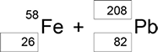

1 mark for each correct box
3
(ii) (a) neutron
1
(iii) 4.0 × 10⁻⁴ (s)
or
0.0004
3.00 × 10⁸ × 0.1 = 12 000 / t
gains 1 mark
2
(iv) particles need to travel a large distance
1
equipment would have to be very long
1
with circular paths long distances can be accommodated in a smaller space
1
(c) (i) the average time for the number of nuclei to halve
1
the time for count rate to halve
1
(ii) 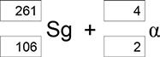

1 mark if top boxes total = 265
and bottom boxes total = 108
1 mark for 4 and 2 for alpha
2
(d) (i) 3 plotted points
± ½ small square
1
best line through points
1
(ii) 190−205 (pm)
or correct from student’s line
1
[20]
Q14.
(a) inside the Sun
1
(b) fusion
1
(c) energy
1
[3]
Q15.
(a) (i) splitting of a(n atomic) nucleus
do not accept splitting an atom
1
(ii) Neutron
1
(b) (i) nuclei have the same charge
or
nuclei are positive
accept protons have the same charge
1
(ii) (main sequence) star
accept Sun or any correctly named star
accept red (super) giant
1
(c) (i) any two from:
• easy to obtain / extract
• available in (very) large amounts
• releases more energy (per kg)
do not accept figures only
• produces little / no radioactive waste.
naturally occurring is insufficient
seawater is renewable is insufficient
less cost is insufficient
2
(ii) any one from:
• makes another source of energy available
• increases supply of electricity
• able to meet global demand
• less environmental damage
• reduces amount of other fuels used.
accept any sensible suggestion
accept a specific example
accept a specific example
1
(d) 12
allow 1 mark for obtaining 3 half-lives
2
[9]
Q16.
(a) J
reason only scores if J is chosen
1
(only) stars (about) the same / smaller size / mass as the Sun become black dwarfs
accept smaller than the Sun
accept it is the smallest
accept (only) small stars become black dwarfs
1
(b) (i) become a supernova
or
it will explode
ignore subsequent correct stages
1
(ii) cannot take measurements needed
or
do not have the technology
do not accept cannot measure mass
1
(iii) advances in (measuring) techniques / technology / knowledge
1
(c) any five from:
ignore any information up to the end of the main sequence
Apply the list rule if more than 5 points are made
• star expands (to become)
• a red giant
red supergiant is incorrect
• heavier elements are formed (by fusion)
elements heavier than iron are formed is incorrect
• star shrinks (to become)
• a white dwarf
supernova, neutron star, black hole are incorrect
• star cools / fades
• star stops emitting energy / radiation
star loses all energy is insufficient
5
[10]
Q17.
(a) (same) number of protons
same atomic number is insufficient
1
(b) (i) nuclei split
do not accept atom for nuclei / nucleus
1
(ii) (nuclear) reactor
1
(c) beta
1
any one from:
• atomic / proton number increases (by 1)
accept atomic / proton number changes by 1
• number of neutrons decreases / changes by 1
• mass number does not change
(total) number of protons and neutrons does not change
• a neutron becomes a proton
1
(d) (average) time taken for number of nuclei to halve
or
(average) time taken for count-rate / activity to halve
1
(e) (i) 6.2 (days)
Accept 6.2 to 6.3 inclusive
allow 1 mark for correctly calculating number remaining as 20 000
or
allow 1 mark for number of
80 000 plus correct use of the graph (gives an answer of 0.8 days)
2
(ii) radiation causes ionisation
allow radiation can be ionising
1
that may then harm / kill healthy cells
accept specific examples of harm, eg alter DNA / cause cancer
1
(iii) benefit (of diagnosis / treatment) greater than risk (of radiation)
accept may be the only procedure available
1
[11]
Q18.
(a) (i) nuclear reactor
1
star
1
(ii) nuclei are joined (not split)
accept converse in reference to nuclear fission
do not accept atoms are joined
1
(b) (i) any four from:
• neutron
• (neutron) absorbed by U (nucleus)
ignore atom
do not accept reacts
do not accept added to
• forms a larger nucleus
• (this larger nucleus is) unstable
• (larger nucleus) splits into two (smaller) nuclei / into Ba and Kr
• releasing three neutrons and energy
accept fast-moving for energy
4
(ii) 56 (Ba)
1
57 (La)
if proton number of Ba is incorrect allow 1 mark if that of La is 1 greater
1
accept e for β
scores 3 marks
1
[10]
Q19.
(a) uranium-235
accept any correct indication
1
(b) splits / breaks (into two smaller parts)
nucleus is separated is insufficient
do not accept atom splits – on its own
1
and (two / three) neutrons
1
(c) steam
correct order only
1
turbine
1
generator
1
[6]
Q20.
(a) (i) plutonium (239)
accept Pu / Thorium / MOX (mixed oxide)
do not accept uranium-238 or hydrogen
1
(ii) (energy) used to heat water and
1
produce (high pressure) steam
1
the steam drives a turbine (which turns a generator)
1
(b) Neutron(s) shown ‘hitting’ other U-235 nuclei
one uranium nucleus is sufficient
1
U-235 nuclei (splitting) producing 2 or more neutrons
1
(c) any two from:
• neutrons are absorbed (by boron / control rods)
• there are fewer neutrons
• chain reaction slows down / stops
accept fewer reactions occur
2
[8]
Q21.
(a) forces (within the star) are balanced
if specific forces are mentioned they must be appropriate
1
(b) (i) bigger the mass (of the star) the shorter the ‘main sequence’ period
accept bigger the star the shorter the time
1
(ii) any one from:
• insufficient evidence
• do not know (exact) amount of hydrogen in star
accept do not know (exact) mass of star
• time too long (to measure directly)
• may be other factors (not yet known) that determine length of
‘main sequence’ period
• values are based on theory / calculation
1
(iii) faster than
1
larger stars have a shorter ‘main sequence’ period so they must have the faster (rate of) nuclear fusion
there must be a link between shorter ‘main sequence’ and nuclear fusion, this may be implied from the first marking point
1
the end of ‘main sequence’ happens as the hydrogen in (the core of) a star is used up
or
(since) they use up hydrogen at a faster (rate)
accept more massive stars (are brighter so) release energy faster
1
(c) Marks awarded for this answer will be determined by the Quality of
Written Communication (QWC) as well as the standard of the scientific response. Examiners should also refer to the information in the Marking guidance, and apply a ‘best-fit’ approach to the marking.
0 marks
No relevant content.
Level 1 (1-2 marks)
There is a basic description of what happens to a star much larger than the Sun after the ‘main sequence’ period.
OR
Two stages are correctly named and are in the correct sequence.
Level 2 (3-4 marks)
There is a clear description of what happens to a star much larger than the Sun after the ‘main sequence’ period.
AND
At least two stages are correctly named and are in the correct sequence.
Level 3 (5-6 marks)
There is a detailed description of what happens to a star much larger than the Sun after the ‘main sequence’ period.
AND
At least three stages are named, in the correct sequence. There are no additional incorrect stages given.
Examples of the points made in the response:
extra information
• (the core of the) star runs out of hydrogen
• (the star) expands (to form)
• (the star) cools (to form)
• the core shrinks
• helium starts to fuse to form other elements
• a red supergiant
accept super red giant
do not accept red giant
• (outer layers) explode
• fusion of lighter elements to form heavier elements (up to iron)
• as a supernova
• elements heavier than iron are formed
accept heaviest elements are formed
• core shrinks
• becoming a neutron star
• if mass large enough (core collapses)
• (to form) a black hole
if a correct description and sequence for a star the same size as the Sun and much bigger than the Sun given without clearly indicating which is which is limited to Level 2
6
[12]
Q22.
(a) fusion
do not credit any response which looks like ‘fission’
1
of hydrogen / H (atoms)
credit only if 1st mark point scores
1
(b) fusion of other / lighter atoms / elements
reference to big bang nullifies both marks
1
during supernova / explosion of star(s)
1
(c) the (available) evidence: supports this idea
or
does not contradict this idea
or
can be extrapolated to this idea
or
(electromagnetic) spectrum from other stars is similar to sun
1
[5]
Q23.
(a) answers must be in terms of nuclear fuels
concentrated source of energy
idea of a small mass of fuel able to generate a lot of electricity
1
that is able to generate continuously
accept it is reliable
or can control / increase / decrease electricity generation
idea of available all of the time / not dependent on the weather
ignore reference to pollutant gases
1
the energy from (nuclear) fission
1
is used to heat water to steam to turn turbine linked to a generator
1
(b) carbon dioxide is not released (into the atmosphere)
1
but is (caught and) stored (in huge natural containers)
1
[6]
Q24.
(a) (i) (nuclear) fission is the splitting of a (large atomic) nucleus
do not accept particle/atom for nucleus
1
(nuclear) fusion is the joining of (two atomic) nuclei (to form a larger one)
do not accept particles/atoms for nuclei
1
(ii) energy
accept heat/radiation/nuclear energy
accept gamma (radiation)
do not accept neutrons/neutrinos
1
(b) (i) uranium (–235)
accept U (–235)
ignore any numbers given with uranium
accept thorium
accept MOX (mixed oxide)
do not accept hydrogen
1
(ii) (same) number of protons
accept (same) atomic number
accept (same) positive charge
ignore reference to number of electrons
1
[5]
Q25.
(a) (i) protostar
correct order only
1
red giant
1
black dwarf
1
(ii) Alpha Centauri A
accept any correct indication, eg alpha, centauri, A
reason only scores if Alpha Centauri A is chosen
1
stars (about) same size as Sun form white / black dwarfs
or
very large stars form red super giants / supernova/black hole
it is the same size as the Sun is insufficient
same life cycle as the Sun is insufficient
1
(b) Atomic nuclei inside the star join together
1
[6]
Q26.
(a) a protostar is at a lower temperature
or
a protostar does not emit radiation /energy
1
as (nuclear) fusion reactions have not started
accept heat or light for energy
1
(b) by (nuclear) fusion
accept nuclei fuse (together)
nuclear fusion and fission negates this mark
1
of hydrogen to helium
1
elements heavier than iron are formed in a supernova
accept a specific example e.g. heavier elements such as gold are formed in a supernova
accept heavier elements (up to iron) formed in red giant/red super giant
reference to burning (hydrogen) negates the first 2 marks
1
[5]
Q27.
three lines correct
allow 1 mark for each correct line
if more than 1 line is drawn from a box in List A, mark each line incorrect
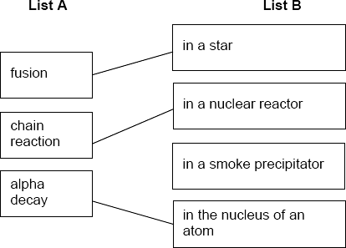
[3]
Q28.
(a) gravitational attraction
accept ‘gravity’
accept (nuclear) fusion
1
(b) radiation ‘pressure’ and gravity / gravitational attraction
must be in correct context
1
are balanced / in equilibrium
accept are equal and opposite
do not accept ‘equal’
or
there is sufficient / a lot of hydrogen / fuel
do not accept constant supply of hydrogen
to last a very long time / for (nuclear) fusion
this mark only scores if linked to the supply of hydrogen / fuel
reference to burning negates both marks
1
(c) (i) (conversion of) hydrogen to helium
accept (conversion of) lighter elements to heavier elements
1
by (nuclear) fusion
note do not credit spelling of ‘fusion’ which could be ‘fission’
reference to burning negates both marks
1
(ii) massive supply / lots of hydrogen
1
(d) distributed throughout the Universe / space
do not accept Solar System for Universe
1
[7]
Q29.
beta
reason may score even if alpha or gamma given
1
any two from:
• mass number does not change
or
total number of protons and neutrons does not change
• atomic / proton number increases by 1
or
number of protons increases by 1
• number of neutrons goes down by 1
allow for 2 marks a neutron splits / changes into a proton and electron / beta
candidates that answer correctly in terms of why alpha and gamma are not possible, gain both marks
2
[3]
Q30.
(a) (forces due to) gravity and radiation pressure
1
correct direction of forces
1
(forces) are balanced / equilibrium / equal
accept for 3 marks an answer in terms of
sufficient hydrogen (1)
to keep fusion reaction (1)
reference to burn / burning negates this mark
going at a continuous /steady rate (1)
if fuel is used instead of hydrogen maximum of 2 marks
1
(b) the Sun will remain stable (for several billion years)
1
based on evidence
accept a specific example of evidence
eg that the Sun has remained stable during the life of our planet / for 4.5 billion years
or
still contains more than 50 % hydrogen
or
by comparison with the lifecycle of (similar) stars
allow a refutation
eg not based on prejudice / whim / hearsay / folk law / historical or religious authority
1
[5]
Q31.
(a) (i) (two) nuclei (of light elements) join
accept hydrogen atoms for nuclei
1
forming a larger / heavier nucleus / one
accept comparative term equivalent to larger
accept forms a helium (nucleus / atom) this mark only scores if fusion is in terms of hydrogen atoms
1
(ii) stars
accept a named star
e.g. the Sun
accept nebula
mention of planets negates answer
1
(b) (i) any one from:
• (currently) only experimental
• reaction does not last long enough
• use more energy than they produce
allow difficult to control
do not allow inefficient on its own
1
(ii) any one from:
• will give another source of energy
• unlimited fuel supplies / energy
accept unlimited hydrogen
• would not produce any radioactive waste
accept less radioactive waste
accept nuclear for radioactive
do not accept toxic waste
• want to show that it can be done
accept any sensible suggestion
do not accept answers only in terms of fossil fuels or carbon dioxide
1
[5]
Q32.
(a) gravitational force(s) (1)
accept ‘gravity’
balanced by (force(s) due to) radiation pressure (1)
accept equal
2
(b) by (nuclear) fusion (1)
of hydrogen to helium (other light elements) (1)
allow ‘low density’ for light
accept hydrogen nuclei / atoms form helium
response must clearly link one element(s) producing others
fusion to produce helium (2)
heavy element / elements heavier than iron are only produced (by fusion) in a
supernova (1)
allow dense for heavy
ignore any reference to elements undergoing radioactive decay (to form other elements)
3
[5]
Q33.
(a) isotopes
1
(b)
1
correct order only
1
(c) (i) (nuclear) fission
accept fision
do not accept any spelling that may be confused with fusion
1
(ii) neutron / neutrons
1
(d) plutonium (239)
accept MOX (mixed oxide)
accept Pu
do not accept uranium 238 / hydrogen
1
[6]
Q34.
(a) (enough) dust and gas (from space)
accept nebula for dust and gas
accept hydrogen for gas
mention of air negates this mark
1
pulled together by:
• gravitational attraction
or
• gravitational forces
or
• gravity
1
(b) forces (in the star) are balanced
accept equal and opposite for balanced
accept in equilibrium for balanced
1
forces identified as gravity and radiation pressure
both forces are required
gravitational forces inwards balance / equal radiation pressure outwards for 2 marks
accept for 2 marks an answer in terms of sufficient hydrogen to keep the fusion reactions going
accept for 1 mark an answer in terms of sufficient fuel to keep the fusion reactions going
1
(c) (explodes as) a supernova
1
any one from:
• outer layer(s) thrown into space
do not accept just ‘thrown into space’
• scatters dust and gas into space (for the formation of new stars)
do not accept just ‘dust and gas’
• elements distributed throughout space
do not accept just ‘distributed’
• matter left behind / core may form a neutron star
do not accept just ‘neutron star’
• a black hole will form if the gravitational forces are enormous / sufficient mass is left behind
do not accept just ‘black hole’
do not accept any references to ‘dark bodies’ or ‘black dwarfs’
black hole forms if star is large enough is insufficient
1
[6]
Q35.
four lines correct
allow 1 mark for each correct line
if more than 1 line is drawn from a box in List A, mark each line incorrect
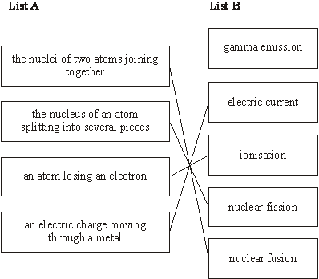
[4]
Q36.
(a) fusion (1)
of hydrogen/H (atoms)(1)
do not credit any response which looks like ‘fission’ or the ‘word’ ‘fussion’
credit only if a nuclear reaction
2
(b) fusion of other/lighter atoms/elements (1)
reference to big bang nullifies both marks
during super nova/explosion of star(s) (1)
2
(c) explosion of star(s)/super nova (1)
reference to big bang nullifies both marks reference to the star running out of energy/material nullifies both marks
at the end of the ‘life’ of star(s) / when they ‘die’ (1)
2
[6]

Q37.
(a)
Particle | Relative Mass | Relative charge
Proton | 1
Neutron |  | 0
accept one, accept +1
do not accept –1
1

accept zero
do not accept no charge/ nothing/neutral unless given with 0
1
(b) equal numbers/amounts of protons and electrons
1
protons and electrons have equal but opposite charge
accept protons charge +1 and electron charge –1
accept (charge) on proton
cancels/balances (charge) on electron
accept positive (charges) cancel out the negative(charges)
neutrons have no charge is neutral
do not accept total charge of protons, electrons (and neutrons) is 0 unless qualified
1
(c) (i) (3) fewer neutrons
accept lower/ smaller mass number
do not accept different numbers of neutrons
any mention of fewer/more protons/electrons negates mark
accept answers in terms of U-238 providing U-238 is specifically stated i.e. U-238 has (3) more neutrons
1
(ii) neutron
1
(iii) (nuclear) fission
accept fision
do not accept any spelling that may be taken as fusion
1
[7]
Q38.
(a) gravitational
accept gravity
do not accept weight
1
(b) (i) planet(s)
accept comet(s)
accept asteroid(s)
do not accept moon(s)
1
(ii) balanced
accept equal / the same / are in equilibrium
1
(iii) Milky Way
accept milky way
1
[4]
Q39.
(a) (i) the bigger the masses (of the dust and gases then) the bigger
the force / gravity (between them)
accept the converse
1
(ii) the greater the distance (between the dust and gases then) the
smaller the force / gravity (between them)
accept the converse
1
(b) radiation ‘pressure’ and gravity / gravitational attraction
these are balanced / in equilibrium
1
must be in correct context
do not accept are equal
or there is sufficient / a lot of hydrogen / fuel to last a very long time
second mark consequent on first
1
(c) any two from:
• hydrogen runs out / is used up
• nuclei larger than helium nuclei formed
accept bigger atoms are formed however do not accept any specific mention of an atom with a mass greater than that of iron
• (star expands to) / become(s) a red giant
2
[6]
Q40.
(a) (i) (nuclear) fission
accept fision providing clearly not fusion
1
(ii) (released) neutrons are absorbed by further (uranium) nuclei
accept hit nuclei for absorbed / hit
do not accept atom for nuclei
1
more neutrons are released (when new nuclei split)
accept for both marks a correctly drawn diagram
1
(iii) increases by 1
or goes up to 236
1
(b) any two from:
• (more) neutrons are absorbed
accept there are fewer neutrons
• (chain) reaction slows down / stops
accept keeping the (chain) reaction controlled
• less energy released
accept heat for energy
accept gases (from reactor) are not as hot
2
[6]
Q41.
(a) (a) supernova (explosion)
1
(b) solar system contains heavy elements / elements heavier than hydrogen
and helium (1)
these (heavy) elements are / were formed by (nuclear) fusion (1)
accept minor misspellings for ‘fusion’
but not anything which could also be ‘fission’
(at the very high temperature(s)) in a super nova / when stars explode (1)
3
[4]
Q42.
(a) dust
accept ‘solid (s)’
1
space
accept ‘from supernova / supernovum / supernovas’
1
(b) By atoms joining together
only one ticked or otherwise unambiguously identified
1
(c) Milky Way (galaxy)
1
(d) The answer depends on beliefs and opinions, not scientific evidence.
only one ticked or otherwise unambiguously identified
1
[5]
Q43.
(a) (i) (nuclear) fusion
allow minor misspellings but do not credit any response which could be fission
1

(ii) (in) stars
accept supernova / red giants / white dwarves
do not allow the Sun
1
(iii) (by) supernova / explosion of star
do not credit just ‘explosion(s)’
1
(b) the (available) evidence:
supports this idea
or does not contradict this idea
or can be extrapolated to this idea
1
[4]
Q44.
The answer to this question requires ideas in good English in a sensible order with correct use of scientific terms. Quality of written communication should be considered in crediting points in the mark scheme.
Maximum of 1 mark if ideas not well expressed
any two from:
dust and gas or remnants of a super nova
accept hydrogen for dust and gas
do not accept hydrogen burns
pulled together by (force of) gravity
nuclear fusion starts
although candidates may include more detail these points are essential to score the credit
[2]
Q45.
(a) (i) (large) nucleus hit by a neutron
1
splits into (smaller) nuclei and neutron(s) (+ energy)
1
(ii) additional neutrons collide with nuclei causing further fission
allow full credit for a correct labelled diagram
accept 2 or more neutrons given out at each fission reaction
diagram shows 3 discernible sizes, with smaller nuclei and neutrons at same stage
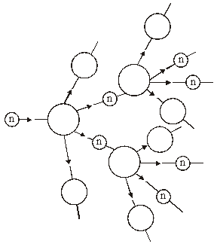
1
(b) cost of (building and) de-commissioning is very high or
cost of building is higher
accept a correct description of de-commissioning
accept high cost to keep the power station safe / secure
accept high cost of reprocessing / storage of nuclear waste
1
(c) less pollution from transport carrying the fuel
accept coal produces more pollutant gases
accept correct named gases
accept more radiation pollution from coal than nuclear
accept more waste from coal than nuclear
do not accept any reference to burning uranium
do not accept answers in terms of global warming or acid rain unless developed
1
[5]

Q46.
(a) any two from:
• nuclei / atoms of light elements fuse
accept hydrogen or helium for light elements
accept join for fuse
accept for 1 mark, by nuclear fusion
answers about fission negates a mark
• each (fusion) reaction releases energy / heat / light
• lots of reactions occur
2
(b) presence of nuclei of the heaviest / heavy / heavier elements
accept atom for nuclei
1
(c) (i) (matter / mass) with such a high density / strong gravitational (field)
1
electromagnetic radiation / light is pulled in
accept nothing can escape
do not accept answers in terms of an empty void
1
(ii) X-rays
accept e-m radiation / e-m waves
1
[6]
Q47.
(a) (i) both lose 2 protons and (2) neutrons
accept changes by 2 protons and 2 neutrons
1
(ii) different number of protons (in the nucleus)
accept different atomic number
do not accept different number of protons and neutrons or different mass number
ignore electrons
1
(iii) gamma involves no change in the number of protons (in the nucleus)
or gamma is a wave (not a particle)
do not accept number of neutrons
and / or protons
ignore electrons
1
(b) (i) water because
both material and reason required
for all energy values the thickness
of water needed to absorb (90% of)
the radiation is more than the other materials
accept thickness of water required is always more
than the other materials
1
(ii) 6
allow 1 mark for obtaining both correct values 72
and 12 from graph
allow 1 mark for incorrect values 71 and / or
11 from graph evaluated correctly
2
(c) any three from:
may be scored on annotated diagram provided
not negated elsewhere
• most (alpha) particles passed
undeflected / straight through the gold
• suggesting most of the atom is empty (space)
• a few (alpha) particles scattered / deflected through (very) large angles
accept repelled
do not accept reflected / rebound /
bounce back
• suggesting a concentrated / small nucleus
• nucleus is positive because it repels the positive (alpha) particles
no reference to experiment, maximum 1 mark
3
[9]
Q48.
(a) fusion
accept fussion
1
energy producing process
accept heat and/or light for energy
accept fussion
1
(b) up to 2 points from:
3 marks for 3 points in sequence with no contradiction
• expands
2 marks for 2 points in sequence with no contradiction
• cools
• forms a red giant
1 mark for a correct point which is not contradicted
up to 2 points from:
do not accept ‘it turns red’
• contracts
• increases in temperature
• forms a white dwarf
ignore further reference to black dwarfs, black holes, nebulae, supernovae
3
[5]
Q49.
(a) (i) centre
1
(ii) protons and neutrons
2
(iii) different number of neutrons
gets 1 mark
heavier
gets 1 mark
3 more neutrons or specified numbers
gets 2 marks
2
(b) atom hit by neutron;
splits into smaller nuclei;
further neutrons released;
neutrons released when one atom splits
cause further fission;
energy released.
any 4 for 1 mark each
4
[9]
Q50.
(i) sensible answers e.g. risk of radioactive leak during transport eliminated
cheaper transport
1
(ii) 4 half-lives 4 × 6 = 24 seconds
3
[4]
Q51.
(i) the nuclei
of hydrogen/smaller atoms
join to make helium/larger atoms
for 1 mark each
3
(ii) the mass of the large nucleus (atom) is less than the mass of the smaller
nuclei (atoms)
for 1 mark
mass loss converted into energy or small mass loss given a large amount of energy
for 1 mark
2
[5]
Q52.
(a) the Sun is subject to two balancing forces / 2 forces in equilibrium
the forces are: gravity making it contract or inward force due to gravity
and a force due to temperature / heat / energy / radiation pressure making it
expand or outward force due to temperature / heat / energy / radiation pressure
for 1 mark each
3
(b) Read all the answer first. Stop after 6 marks.
hydrogen / fuel used up owtte the star will expand and become a red giant
it will contract under gravity become a white dwarf
it may explode and become a supernova throwing dust and gas into space
leaving a dense neutron star / black hole
(no mark for contradiction)
any six for 1 mark each
6
[9]
Q53.
any three from
max 2 if stages but no explanation
• the star (Sun) expands because
(inward) gravitational forces no longer balance (outward) force
accept the star collapses rapidly causing the core temperature to increase and the star to expand
accept it expands because the forces are unbalanced
• to become a red giant
• when the fusion stops it contracts / cools
accept (when hydrogen is used up) it collapses under gravity
accept when fusion stops it contracts and explodes
• to become a white dwarf
accept to become a supernova / pulsar / neutron star / black hole (only if red giant has exploded)
[3]
Q54.
(a) (i) any two from
(matter from) exploded star / supernova
matter so dense / gravity so strong
that electromagnetic radiation / light cannot escape from it
2
(ii) X-rays emitted
1
when gases or matter released from nearby stars spiral into it
1
(b) fusion (of nuclei)
1
of lighter elements / hydrogen helium
1
[6]
Q55.
Quality of written communication: One mark for using correct scientific sequence :
gravity → fusion → balance
1
any four from
• (dust and gas) pulled together by gravity
• (star formed when) it is hot enough
accept (as mass is pulled together) it gets very hot
• hydrogen (and helium) nuclei fuse
• (these nuclear fusion reactions) release the energy / heat / light
(which is radiated by stars)
• energy causes expansion
• gravitational pull is balanced by the expansion (force)
4
[5]
Q56.
(a) materials produced when earlier stars
exploded
accept the Sun is a second generation star
accept formed from nebulae
1
(b) Quality of written communication:
1 mark for correct sequencing balanced forces → expansion → contraction / explosion
1
any five from
gravity pulling matter together
accept idea that a star is very massive so its force of gravity is very strong
high temperatures that create expansion forces
nuclear fusion releases energy that causes the very high temperatures
these forces balance
star expands greatly
since expansion is greater than gravity
accept fuel runs out
forms a red giant
give no further marks if red giant → white dwarf, red dwarf etc
collapses inwards and explodes outwards
called a supernova
neutron star may form
leaves a small, dense object (a black hole)
accept nothing can escape from it
5
[7]
Q57.
any one of
* between (stage) 2 and (stage) 3
* (in) the main sequence
* (in) the main stable period
* (it is a) yellow dwarf
[1]
Q58.
(a) evidence of conclusion 4 × 1.007825 or 4.0313
each gain 1 mark
based on use of data that there is a (very small) loss of mass
or 0.0276 but a loss of mass of 0.0276 for every helium atom or 0.69%/0.7%
gains 3 marks
3
(b) idea that loss of mass results in release of energy
gains 1 mark
but small loss of mass results in huge energy release
gains 2 marks
2
[5]
Q59.
(a) it use E = mc²
mass in kg i.e. 0.001 ×

each gains 1 mark
but 000007
gains 2 marks
2.1 × 10³
gains 3 marks
evidence of 0.000007
mass in kg (i.e. 0.0007 or 0.7/100000)
each gains 1 mark
squaring the speed of light
but 6.3 × 10¹¹ (credit alternative ways of stating this)
gains 3 marks
units J/joule
for 1 further mark
(N.B credit kJ, MJ, GJ but check power of 10 for full credit)
4
(b) (i) idea that the bigger the mass the shorter the life
gains 1 mark
but idea that decrease in life is much more than
proportional to increase in mass
or more than proportional to mass²
gains 2 marks
2
(ii) ideas that:
greater mass means greater core temperature/pressure
greater core temperature/pressure means greater rate of fusion
increase in mass produces a proportionally much greater
increase in the rate of fusion
each for 1 mark
3
[9]
Q60.
ideas that
• formed from dust/gases
• pulled together by gravity
• massive so very large gravitational forces (pulling inwards)
• hydrogen → helium / fusion releases energy [not fission or just ‘nuclear’]
• high temperature creates high pressure (pushing outwards)
• long period when forces balance
• then expands → red giant / red star
• then contracts to (dense) white dwarf / white star
[credit if massive enough / more massive than sun, red giant → supernova → (very dense) neutron star but do not accept w.r.t. Sun itself]
[The whole of the (non bracketed part of) each idea must be present in some appropriate for in of words for each mark to be credited. To gain more than a single mark ideas must also be in correct sequence and/or appropriately related.]
any six 1 mark each
[6]
Examiner reports
Q1.
(a) Just over 80 % of the students scored 2 marks for correctly describing what is meant by an isotope of an element. The number of electrons was ignored as this does not define an isotope.
(b) Students needed to say light / lighter / small nuclei to demonstrate they understood that it is only lighter nuclei which fuse. The word fuse could have been substituted for other words like ‘join’, or ‘combine’ but ‘collide’ was insufficient. Some students demonstrated an excellent understanding of the fusion process and fusion in stars was accurately described. Fusion on earth where an extra neutron is released was ignored, as the process as stated in the specification was being tested. Just fewer than 20 % of the students scored 3 marks, while nearly 30 % of the students scored 2 marks and approximately 15 % of the students scored 1 mark.
(c) Most students who scored a mark did so for stating that the reactor walls should not melt. Few students scored the first marking point. Most students were vague and used phrases like the walls need to ‘withstand the high temperatures’ which did not score a mark. Many students confused specific heat capacity with thermal conductivity and thermal insulation. Containing the fusion energy or products was another common insufficient response. Only about 4 % of the students scored 2 marks, while approximately 40 % of the students scored 1 mark.
(d) Just over 30 % of the students scored the mark for the consequence of an uncontrolled chain reaction. ‘Explosion’ unqualified was insufficient to score the mark.
Q2.
Foundation
(a) 15 % of students scored 3 marks, 39% scored 2 marks and 30% scored 1 mark. The most common mark to score was either ‘nuclei’ or ‘gamma rays’.
(b) In this exam series all equations were provided for the students on the Physics Equations Sheet. 94% of students scored the mark.
(c) 67% of students scored 2 marks for multiplying the power by the time, whether they had converted the power or not. Most attempts to convert the power were incorrect. Only 3% of students scored all 3 marks for this calculation of energy.
(d) 13% of students scored a mark. ‘Wear protective clothing’ or ‘hazmat suits’ were common incorrect answers. Any idea of burying the radioactive waste was credited, so ‘bury it in a field’ was ok, as was ‘bury it in landfill’, which from a student’s perspective is equivalent to burying it underground. ‘Keeping it away from people’ was insufficient.
(e) 74% of students scored 2 marks, while 3% scored 1 mark. The answer of 29.2 days was worth 1 mark as this could only have been calculated by doing the correct calculation and then subtracting the result from 365.
Higher
(a) A sentence completion question about nuclear fission which discriminated well between students. 72 % of students scored 3 marks, 21% scored 2 marks and 5% scored 1 mark.
(b) 99.5% of students scored the mark for writing down the correct equation. However, in this exam series all equations were provided for the students on the Physics Equations Sheet.
(c) A standard demand calculation of energy question. 48% of students scored 3 marks, while 41% of students scored 2 marks. Not converting or incorrectly converting the unit will have allowed many students to only score 2 marks.
(d) 44% of students scored a mark. ‘Wear protective clothing’ or ‘hazmat suits’ were common incorrect answers. Any idea of ‘burying it’ was credited, so ‘bury it in a field’ was ok, as was ‘bury it in landfill,’ which from a student’s perspective is equivalent to burying it underground. ‘Keeping it away from people’ was insufficient.
(e) 96% of students scored 2 marks. The answer of 29.2 days was worth 1 mark as this could only have been calculated by doing the correct calculation and then subtracting the result from 365.
Q3.
(a) 47% of students correctly identified the particle.
(b) 86% of students scored 2 marks on this calculation question.
(c) 57% of students correctly identified the charges.
(d) 75% of students correctly identified the description of the force.
(e) 78% of students identified the correct alpha particle.
(f) 39% of students answered correctly. ‘Tiny spheres’ was enough to score the mark for students who could not manage to write all 6 words.
(g) 23% of students identified the correct model.
Q4.
(a) 29% of students scored 2 marks, while 27% of students scored 1 mark for this question about isotopes.
(b) 51% of students knew what half-life means.
(c) 77% of students correctly identified the least stable isoptope.
(d) Students found this question difficult with only 38% scoring 2 marks and 21% scoring 1 mark for this question about irradiation and contamination.
(e) 68% of students identified the purpose of the sticky floor.
(f) 72% of students scored 2 marks on this calculation question.
(g) This question discriminated well with 46% of students scoring 2 marks and 20% of students scoring 1 mark for this question about fission and fusion
Q7.
(a) 40% of student scored a mark on this question. Electronics, microwaves, phones and food and drink were common incorrect responses. Man-made doesn’t mean ‘made by man’ in this context it refers to the radiation source being artificial rather than naturally occurring. Incorrect answers commonly seen included things which are not man-made, eg sunlight, cosmic rays, other types of radiation which do not contribute to background radiation like microwaves or infrared.
(b) 74% of students could name a nuclear fuel. The most popular answer being ‘uranium’. Commonly seen incorrect answers included coal, oil, gas and petrol.
(c) Only 6% of students scored all 4 marks. To score the first marking point, students needed to indicate that the neutron becomes part of the U-235 nucleus, it was insufficient to only say that the neutron collides with the nucleus. Very few students scored the 4th marking point. Many students hadn’t revised the process, evidenced by their meandering discussion of different radiation types and gold sheets. Whilst many students had some idea of the nuclear fission process, they often failed to gain marks because their answers lacked detail or were imprecise, eg neutrons being absorbed by ‘atoms’ rather than ‘nuclei’, a nucleus ‘splitting’ without the detail of two daughter nuclei being produced. A number of students went on to describe the chain reaction and / or the process of electricity generation which was unnecessary.
(d) Only 8% of students scored both marks, with 29% of students scoring 1 mark. Elements fuse or atoms fuse was insufficient. Nuclei fuse was insufficient unless they said to form a larger / heavier nucleus. Very few knew that some of the mass of the nuclei was converted into energy. Some students fell back on their knowledge of chemical reactions and mentioned breaking bonds and exothermic reactions.
(e) Only 8% of students scored 2 marks, 39% of students scored 1 mark. Very few students linked the short half-life to how the activity of the waste would change with time. Most students who scored the first marking point did so for saying the radioactive waste would decay quicker. Students tended to score the second marking point rather than the first, although vague statements like less harm/damage to the environment were insufficient.
Q8.
(a) More than 90% of students were able to gain at least one mark, usually for identifying gamma rays as the radiation released. Around one quarter scored all three marks.
Common incorrect answers were ‘a uranium neutron’ along with ‘absorbs a proton’.
(b) Around two thirds of students scored both marks. The value obtained by dividing the given values was 10.4 and many students thought about the context of the question and realised that therefore 11 power stations would be needed. The main error was rounding down to 10, which allowed a further 20% of students to score one mark.
A few students multiplied the two numbers given to get an answer of 6 × 10¹³ power stations.
(c) Only 6% of students scored both marks, with a further 25% scoring one mark. The most common correct answer was a reference to radioactive waste. Some referred to the potential for a catastrophic accident to score a mark.
Those who failed to score marks often referred to the waste as being ‘harmful’ without specifying why this was the case. Many students seem to think that ‘harmful radiation’ is given off all the time from a nuclear power station. There is also a common misconception, that nuclear power stations produce carbon dioxide.
(d) Just under half of students scored both marks by stating the similarity as the increase in both carbon dioxide concentration and global temperature and the difference in the pattern after the year 2000.
A number of students failed to score marks because they selected spurious data, for example that they both graphs went from the year 1900 to past 2000 but had different numbers on the y-axis.
Q9.
(a) 11% of students scored 3 marks, 27% of students scored 2 marks. Lots of thorough answers were seen, but they needed to state the advantages of nuclear, rather than disadvantages of shale gas. ‘Shale gas releases CO₂’ did not score a mark, but ‘nuclear does not release CO₂’ did score a mark. Information about shale gas was given in the question, which is why these answers were insufficient for a mark.
(b) 66% answered this question correctly. The most common correct answer was uranium. A common incorrect answer seen was oil.
(c) Many good answers seen with 12% scoring 4 marks and 20% scoring 3 marks. Some students didn’t mention the nucleus absorbing the neutron or the nucleus splitting in two, so they didn’t score the first two marking points. The first marking point was the least likely to score. The third marking point was scored by most students.
Q11.
(a) Few of the students correctly gave 'neutrons'. The most popular answer was 'protons'.
(b) There were many incorrect answers such as ' power stations ' with the students not stating that in most nuclear reactors the energy released was to heat water to eventually generate electricity. Many students simply wrote the word "electricity" and did not score the mark.
(c) (i) Again few students correctly identified particle X as 'a neutron'.
(ii) Half of the students scored zero. A common error was to show only one neutron released from each U-235 nucleus or to show only one fragment produced. Others students showed 2 neutrons released from the given U-235 nuclei but did not show any fragments. A small number of students who did this went on to draw further U-235 nuclei which then released neutrons. This gained both marks as it did show the start of a chain reaction.
Q12.
(a) (i) Nearly half of the students failed to score a mark, with the other half split roughly equally between 1 and 2 marks. Many good answers were as per the mark scheme, with the term nebula quite often used for dust and gas. Incorrect responses included "rocks in the atmosphere / air", or dust on its own. Many students also did not refer to gravity being the attracting force. Many students incorrectly referred to fission. Some students referred to fusion, but this was not relevant to the question.
(ii) Just over a third of the students scored this mark. The most common error was to use "atom" for nuclei. Some students confused fusion and fission. This question was not attempted by a significant minority of the students.
(iii) "Better / Improved Technology ", was the most frequent correct answer given. Quite a few answers confused telescopes with microscopes. Similarly satellites were often mentioned without any further indication how they might improve observations. Some students did not score the mark because they thought that the reason scientists had not detected them before was because they did not know what to look for or because light from these stars had only just reached us (in order to be observed).
(b) (i) "Other/different Planets", was the most common correct answer, scored by just over half of the students. It was strange to see that many students mentioned that the evidence might have proved there were other life forms in the universe as this didn't seem to be linked to the question.
(ii) Although the mark was scored by nearly half of all students, many correct answers were imprecise in their explanation of "proving / supporting ", the theory.
(c) Nearly one tenth of the students did not attempt this question. Of those that did less than a quarter scored the mark, as students failed to identify the key idea of "only". Too often the information in the stem of the question was fed back using slightly different words or simply the same words in a slightly different order.
Q13.
(a) (i) Two thirds of students scored both marks. Those failing to score often confused which particle had the same number and which had different numbers or included incorrect references to electrons but more commonly referred to ‘elements’ rather than ‘an element’ or ‘atoms’. Few students scored the marks by referring to atomic number and mass number.
(ii) Nine tenths of students gained the mark on this question for identifying the atomic number.
(iii) Similarly, nine tenths of students gained the mark on this question for correctly calculating the number of neutrons.
(b) (i) More than half of students gained all three marks here. Poor arithmetic was as much to blame as poor understanding for those who made mistakes.
(ii) Three-quarters of students correctly identified the neutron. Incorrect answers included electron, proton, hydrogen, uranium and gamma.
(iii) Half of students gained both marks, but nearly as many scored zero. The most common mistake was to not recognise the speed of the iron nuclei as one-tenth the speed of light resulting in their answer being incorrect by a factor of ten. Omitting the 0.1 gave a value of 0.00004 but often seen was some other power of 10 error - possibly due to calculator misuse. Occasionally students rearranged incorrectly and got a value of 2500. The use of standard form was not as common as hoped; approximately half the correct answers were not in standard form and many partially correct answers were expressed as a fraction.
(iv) Three fifths of students scored zero marks on this question. Very few realised that a linear accelerator would need to be very long, while a circular accelerator could be built in a smaller space. Some students described acceleration in a circle and centripetal forces. Many students clearly did not understand what the question was asking.
(c) (i) Nearly all students gained at least one mark and three-quarters gained both. Some students failed to tick two boxes.
(ii) Two thirds of students gained both marks. Most students realised that the combined mass numbers and proton number should total 265 / 108. There were often unusual mass and atomic numbers written for the alpha particle; 0 & -1 were often seen, but also numbers containing figures to the right of a decimal point and numbers greater than 4.
(d) (i) Two thirds of students scored both marks for correct plotting and a suitable line of best fit. Only a small number of students did not draw a straight line. Some straight lines were drawn to far from the data and so did not score a mark. Mis-plotting could lead the student to draw a curve and these were accepted if they were drawn well.
(ii) Nine tenths of students gained the mark for correctly extrapolating the line and estimating a suitable number.
Q14.
(a) Just under half of the students scored this mark.
(b) Just over three quarters of the students scored this mark.
(c) This mark was scored by just over three quarters of the students.
Q15.
(a) (i) Less than half of the students scored this mark. The most common error was to use colloquial terminology of ‘splitting the atom’ rather than referring to the nucleus.
(ii) Just fewer than half of the students named the particle as a neutron to score this mark. Common errors were ‘alpha particles’ or ‘Uranium 235’.
(b) (i) Although this was quite accessible, many of the students simply quoted a rule like ‘like charges repel’ without relating their answer to nuclei. Others did not interpret the question properly and attempted to explain about forces within the nucleus or between the nucleus and electrons. About half of the students scored this mark.
(ii) This question was better answered with most of the students scoring the mark. The students that failed to score the mark either gave far too general answers like ‘in space’ or focussed on other contexts − both biological and geological − with references to fertilisation and to volcanoes.
(c) (i) Many students had a good attempt at this question with almost half of the students scoring one mark and a further third scoring both. Many students gave an economic argument which was not creditworthy.
(ii) This was poorly answered. Correct answers were not common, but referrals to reducing reliability on other fuel sources and reducing environmental damage were the most frequent. In suggesting an important consequence of developing fusion technology, many students expressed concern over the release of radioactive material, meltdown and references to the reactors running out of control. Incorrect responses like ‘difficult to dispose of the radioactive waste’ or ‘lots of carbon dioxide emissions’ were common.
(d) Of those students that did attempt an approach which resembled a half-life calculation, those that identified there were three half-lives were awarded one mark and in most cases these students went on to correctly calculate the answer and score both marks. There were a significant number of students who identified the sequence 80-40-20-10 and then incorrectly thought this made four half-lives and another group that divided into 36 years to arrive at an answer of 4.5 years. Only one third of the students scored both marks.
Q16.
(a) Most of the students scored very well here, with nearly three quarters gaining both marks. ‘J’ was usually seen with ‘it is the smallest’. Some students tried to elaborate further and ended up by confusing their answer. Another popular answer was ‘(only) small stars become Black Dwarfs’.
(b) (i) Both ‘become a supernova’ and ‘it will explode’ were seen here although only one response was needed. About a quarter of the students scored zero and those that did often had either a subsequent incorrect stage written down or ‘it will implode’.
(ii) This was not done very well with over four fifths of the students scoring zero. Most of the students mentioned the lack of weighing machines or another method for measuring the mass. Another popular response was the idea that we cannot visit Betelgeuse.
(iii) This was generally done very well with half of the students giving one of the responses involving advances in measuring, scientific knowledge, or technology. Unfortunately a few of the students continued with the idea of technology extending to the building of spaceships enabling people to visit Betelgeuse.
(c) This was usually done well, with two fifths of the students scoring 3 or more marks. Some of the students were very unsure of the different stages and just wrote down Red Giant and White Dwarf and this enabled them to obtain two marks. The last stage was a little confusing to some of the students as they wrote about the star losing all of its energy or running out of energy rather than the star stopping emitting energy.
Q17.
(a) Nearly three fifths of the students gave the correct answer, ‘number of protons’. Many of the students did not understand the term ‘in common’ and instead, wrote about the differences between isotopes.
(b) (i) About two fifths of the students correctly stated that nuclei are split in nuclear fission. Most of the remaining students had an idea of what happens but used ambiguous and vague terminology, using ‘break apart’, ‘divide’ ‘particles’ without supporting explanation and thus lacked sufficient clarity to obtain the mark.
(ii) A lack of clarity again stopped students obtaining this mark with only about two fifths naming the reactor as the part where molybdenum is produced.
(c) About two thirds of the students identified the radiation as beta. However the reasons given were often confused, imprecise and sometimes contradictory. Examples seen include: ‘atomic number stays the same but number of protons goes up’, ‘nucleus loses a proton and gains a neutron’, ‘nucleus loses a neutron but gains a proton and an electron’, etc. Less than a third of the students gave complete answers that correctly gave the marking points in the mark scheme.
(d) Only less than a third of the students gave answers sufficient to score the mark. A small proportion of the students gave an answer in terms of the count rate halving.
(e) (i) About two thirds of the students recognised that the number remaining was 20,000 but then less than half of these students used the graph to correctly identify 6.2-6.3 days as the time required. A small amount of students drew lines on the graph at 80,000 and identified 0.8 days but half of them, then carried out further calculations on this and consequently lost the compensation mark.
(ii) Fewer than a third of the students scored the mark for the ionising effect of radiation; of those who did, they usually went on to score the second mark. Most of the students that scored the second mark did so for general terms about radiation ‘causing cancer’ or some form of harm. Few students linked the ionising effect of radiation to damage or harm to individual cells or DNA.
(iii) Many of the students reiterated statements from part e(ii) about the dangers of radiation rather than answering the question asked. Students’ phrasing of their response was often confused with only about a fifth being able to describe that the benefits outweighed the risks.
Q18.
(a) (i) Nearly all students knew that nuclear fission takes place within a reactor and that nuclear fusion takes place within a star.
(ii) Less than half of the students could state a way in which fusion differs from fission. Many statements referred to atoms or elements instead of nuclei.
(b) (i) A nuclear equation representing fission was given and students were asked to use the information in the equation to describe the process of fission.
This was well answered, with just under half of the students gaining all four marks. Many statements relating to fission were seen which ignored the given equation. For example ‘two or three neutrons are released’ when the equation clearly showed three.
(ii) Only a quarter of students could complete a nuclear equation depicting beta minus emission by adding subscripts for atomic number and a correct symbol for a beta particle.
Many students are unclear concerning the symbol, subscript and superscript for a beta particle.
Q19.
(a) A majority of students gave the correct answer. The most popular incorrect answer was plutonium.
(b) Over half of the students scored zero with a significant minority not attempting the question. Most students got confused between nuclei splitting and atoms splitting and most students forgot about the neutrons that are released.
(c) This was better answered with nearly half of students scoring all three marks. A common error was to interchange the position of the turbine and generator.
Q20.
(a) (i) Nearly two thirds of students scored this mark with the main incorrect answer being uranium; a very few candidates gave thorium instead of plutonium.
(ii) Despite the instruction to the contrary, too many students simply described the fission process. Marks scored tended to be 0 or 3. A significant minority of students did not attempt the question. The most common error in the good attempts tended to be to replace the turbine with the generator, although propellers and rotators were also erroneously mentioned. Those students who answered successfully demonstrated a clear and detailed knowledge of the process, by describing the whole process, including the turbine driving the generator.
(b) The students who knew how to approach this diagram did well. Unfortunately a significant minority of students did not even attempt the diagram. The most frequent error was showing the process as continuing from the two daughter nuclei shown. Often candidates seemed to have an idea of the process but either failed to show it clearly, or did not use labels to support poor diagrams.
(c) Most students who scored at least one mark did so by knowing neutrons were absorbed by the boron, although they often failed to make this absolutely clear. The descriptions for the third marking point too often failed to earn credit, by simply writing as a result “less energy released”.
Q21.
(a) Very few students gained this mark. Most responses did not have any reference to forces or that the forces would be balanced.
(b) (i) This was well answered with the majority of the students being able to identify the relationship between the relative mass of the star and the estimated time.
(ii) This was poorly answered with many vague responses in terms of stars being ‘different’.
(iii) Just over half of the students gained one mark for correctly choosing ‘faster than’. However these students often went on to simply give a repetition of the question as the explanation. Few students referred explicitly to the time spent in the main sequence, instead using terms like ‘its life is shorter’.
(c) This was very poorly answered with a significant minority of students scoring zero. A small amount failed to attempt the question. The better students knew the stages that a large star passes through after the main sequence period but were often unable to give a description of what happens to a star. Simple statements such as ‘it expands to give a red supergiant’ were sufficient to gain some credit. A significant number of students described the life cycle up to the main sequence period whilst others described the lifecycle of the Sun. The vast majority of the students seemed to simply put down everything they could think of in a totally random order. Many students were very creative, with new types of stars being named, black holes forming new stars and the complete life cycle being described in terms of a butterfly!
Q22.
(a) Just over half of the students scored both marks. Some students failed to use the term “fusion” in respect of the conversion of hydrogen to helium.
(b) A small number of students scored both marks and nearly half scored one mark, usually for the “supernova”.
(c) Three-quarters of the students scored zero. There was little reference to evidence and most of the students merely said “the Big Bang”.
Q23.
(a) The term ‘nuclear fission’ was well known. However, it is alarming how many students think that nuclear fuels are burned in order to release energy. The process of generating electricity was not well described; many students seem to think that it is the turbine that generates the electricity. An advantage of nuclear fuels ‘reliability’ was often given. However, many students spent a lot of time and filled a lot of space describing numerous disadvantages of nuclear energy and / or the advantages and disadvantages of wind with no reference at all to nuclear energy.
(b) Nearly a fifth of students did not attempt this question. Many students simply repeated the stem of the question and had no idea about the storage of the carbon dioxide following its ‘capture’. A common error was the assumption that ‘carbon capture’ involves the removal of the existing carbon dioxide from the atmosphere.
Q24.
(a) (i) Only 8% of students could explain the difference between nuclear fission and nuclear fusion. Only a further 7% could describe one of the processes correctly. The majority of answers simply stated that fusion was natural and fission happens in power stations.
(ii) There were a large number of different answers given, unfortunately few were correct. Approximately 37% of students did gain a mark, generally for either energy or heat.
(b) (i) Just over 20% of students failed to attempt this question despite it being a straight recall of information from the specification. Approximately 35% of students gave a correct answer.
(ii) Only 22% of students gained this mark. The most common error was to state that the number of neutrons would be the same.
Q25.
(a) (i) Nearly two-thirds of students scored the maximum of three marks by correctly sequencing the three stages of one type of star. A common error was to include ‘black hole’ in the sequence.
(ii) Over two-thirds of students chose the correct star. However, there were few correct reasons given for their choice, many students simply restating the similarity of the size of Alpha Centauri A and the Sun from the table.
(b) Only a third of students could correctly identify the process by which energy is given out in stars.
Q26.
(a) Many students were able to recall that main sequence stars undergo nuclear fusion, although there were a number of students who thought that protostars also undergo fusion, but at a slower rate. The spelling of fusion was not always clear, with some students putting a dot / dots above what may have been the letter ‘u’ or ‘ii’; this was taken as being fission and so did not score a mark. Many students were aware that protostars are not giving off energy / radiation whilst main sequence stars are. A small number of students attempted to describe the life cycle of a star.
(b) Surprisingly, less than two-thirds of students knew fusion was involved. Many students had hydrogen fusing to form the heavier elements, rather than helium. Few students recalled that elements heavier than iron are formed in a supernova. A significant number of responses allocated a role to the planets and made reference to the ‘Big Bang’.
Q27.
This question demonstrated the need for candidates to learn basic facts. Just over a quarter of candidates scored zero and a further two-fifths scored only one mark. There was a large variety of incorrect links, one of the most common being a chain reaction happening in a star.
Q28.
(a) Just under three-quarters of candidates scored this mark, with most answers given in terms of gravitation.
(b) There were two alternative ways to answer this part question. Even so, only a fifth of candidates managed to score both marks. Some candidates did not refer to ‘radiation pressure’ correctly although the idea was inherent in their response. Some candidates did not include the direction of the forces involved. There were a significant number of candidates who lost marks by references to ‘burning’ hydrogen / fuel.
(c) (i) Just over half of the candidates scored one mark. However, some lost marks by references to ‘burning’ and others to ‘fission’.
(ii) Few candidates scored this mark. There were few references to the amount of hydrogen in a star.
(d) Again this question was poorly answered with only two-fifths of candidates scoring the mark. It was evident that some candidates do not take notice of the space and mark allocation given to questions and gave extensive, usually incorrect, responses to this question.
Q29.
Just over a quarter of candidates gained full marks by either commenting on the mass number and atomic number or identifying the neutron decaying to a proton and electron. A number of candidates wrongly thought the proton number decreased and confused the atomic number with the mass number, although a further fifth of candidates were able to gain two marks. A further quarter of candidates scored one mark for correctly identifying beta, without being able to explain why. A number of candidates incorrectly identified the radiation but then went on to give a correct explanation for beta radiation.
Q30.
(a) Considering how often this or a similar question has been asked it is surprising that few candidates gained all three marks. Weaker candidates gave vague responses such as‘forces are equal’ without being specific about the type of forces or their direction. Some candidates took the alternative route of saying that there is sufficient hydrogen available to keep the fusion reactions going for a long time but there was rarely a reference to this happening at a continuous/steady rate.
(b) Most candidates correctly identified the opinion as being‘that the Sun will remain stable for several billion years into the future’, but then failed to give the idea of evidence or correct usage of the facts given in the passage to suggest how scientists could justify this.
Q31.
(a) (i) This was not answered well. The principal errors were candidates responding in terms of atoms, rather than nuclei, and descriptions based on fission processes.
(ii) Few candidates were aware of the site of nuclear fusion reactions, with common misconceptions placing this process within volcanoes or the atmosphere.
(b) (i) Just under half of the candidates were able to state why nuclear fusion reactors are not used to produce electricity from the information given. Many incorrect responses were in terms of vague statements involving doubts about the safety aspects of nuclear power in general.
(ii) Unfortunately, most candidates suggested that the sole reason for the continuing search for sustainable nuclear fusion in a reactor was due to issues involving fossil fuels and carbon dioxide and did not receive credit.
Q32.
(a) A number of candidates realised the importance of gravity but fewer candidates used the term ‘radiation pressure’ to score both points.
(b) Most candidates stated that nuclear fusion is the process by which other elements are formed and some candidates were able to give hydrogen to helium and other ‘light’ elements as examples. However, only a small minority of candidates were able to indicate the conditions required to form ‘heavy’ elements. Some candidates confused their answers by referring to chemical reactions.
Q33.
(a) This mark was scored by over three quarters of candidates, the common incorrect answers were ‘isomers’, ‘allotropes’ and ions.
(b) There were many correct answers, with relatively few candidates getting only one of the numbers correct.
(c) (i) There was the usual illegible and poor spelling of ‘fission’ where it was difficult to see if the candidate had written a u or an i. Many of the candidates gained the mark.
(ii) Only just over half of candidates were able to recall this, with nucleus and electron being common incorrect answers.
(d) Just over half of candidates were able to correctly identify plutonium, although the spelling was often incorrect. Polonium was a common incorrect answer along with potassium. The ‘acceptable’ answer of MOX was rarely seen.
Q34.
(a) Most candidates gave at least one of the correct responses although some lost credit by listing contradictory points. Some candidates gave the full life story of a star which necessitated the use of additional pages even though they had gained the marks in the first sentence.
(b) Only a minority of candidates gained the two marks by recognising radiation pressure as one of the factors involved. A significant number of candidates gave correct responses in terms of fusion although a minority of candidates gave answers involving either fission or the burning of hydrogen.
(c) As in part (a), candidates gave very long responses requiring extra sheets or answers out of the clip area; in some of these longer responses, candidates contradicted themselves. Most candidates gained one mark for ‘supernova’ but very few gave a correct explanation of what happens next.
Q35.
This question was accessible to all candidates with most showing a good understanding of these key processes. The majority of candidates scored three or four marks.
Q36.
Many candidates ‘confused’ chemical reactions with nuclear reactions. They should note that there are nuclear fusion reactions and nuclear fission reactions. Candidates who did not clearly refer to the correct term did not gain credit.
Q37.
Foundation Tier
(a) The relative mass and relative charge of the subatomic particles was not well known by most candidates with few scoring both marks. Some candidates clearly did not understand the question giving answers of ‘–1’ or ‘2’ for relative mass.
(b) This question was poorly answered. Very few candidates scored both marks. In most cases, where one mark was scored, candidates were able to get over the idea of positive cancelling negative in some way but very few gained the mark for stating that the number of protons and electrons was equal.
(c) (i) The variety of answers given meant that the vast majority of candidates did not score this mark. Many candidates only said that uranium-235 or uranium-238 contained a different number of neutrons rather than being more specific and stating that uranium-235 had fewer neutrons.
(ii) Few candidates knew which subatomic particle caused the splitting of atoms in a nuclear reactor. The variety of answers seemed to indicate a lot of guesswork taking place.
(iii) Very few candidates knew the correct scientific name for the process. Many candidates named chemical processes and nearly 20% of all candidates left the answer space blank.
Higher Tier
(a) Most candidates scored both marks. However some candidates indicated they were not really understanding the question by putting ‘-1’ for relative mass.
(b) Few candidates scored both marks. Most scored one mark for suggesting that the charges cancelled but few mentioned that the numbers of electrons and protons was the same.
(c) (i) The majority of candidates did not know the correct answer and tended to state that there were ‘different numbers of protons or/and neutrons’
(ii) Almost half of the candidates scored this mark. Popular incorrect answers included ‘nucleus’ and ‘alpha particle’
(iii) Most candidates scored this mark. The candidates who did not, often cited chemical processes such as diffusion, electrolysis, cracking or the Haber process.
Q38.
(a) A large majority of candidates identified the force as gravitational.
(b) (i) A small minority of candidates were able to offer a correct response with ‘bigger stars’ as a popular incorrect answer.
(ii) A majority of candidates were able to offer a correct response.
(iii) A majority of candidates scored the mark but it is of concern that some candidates suggested universe, Earth or moon as possible names for our galaxy.
Q39.
(a) (i)(ii) Most candidates were able to express correctly the relationships between gravity and the mass of the dust and gas and between gravity and the distance apart of the dust and gas.
(b) About half the candidates scored at least one mark as credit was given for an explanation of why the star remains stable or why this period lasts for millions of years. Two marks were given for a response which correctly refers to both aspects, eg ‘the forces acting inside the star are balanced and the star has a vast supply of hydrogen’.
(c) Just over a third of candidates obtained at least one mark. However, some candidates demonstrated their lack of understanding by suggesting that, in stage 4, nuclear reactions start or that a star is formed.
Q40.
(a) (i) This was usually correct, and correctly spelt.
(ii) This was quite well done, with many candidates finding it easier to show diagrammatically what was happening. A large number referred to uranium atoms rather than nuclei.
(iii) Less than 50% of candidates scored this mark. There were many vague ‘it goes up’ responses.
(b) A number of candidates did not attempt this question. However many candidates were able to apply their knowledge of a chain reaction and the information given in the question to gain full marks. A common erroneous answer was in terms of an increase in gas pressure due to lowering the rods
Q41.
(a) Nearly all candidates recognised that the reference at the end of the passage is to a supernova, though some suggested the big bang.
(b) Most responses were disappointing and did not gain any marks. Few candidates answered in terms of elements and consequently even fewer explained that atoms of the heaviest elements can only be formed by nuclear fusion at the very high temperatures of a supernova.
Q42.
(a) The majority of candidates gained at least 1 mark.
(b) Just under a third of candidates knew that stars are able to give out energy for millions of years by atoms joining together.
(c) Three quarters of candidates correctly identified ‘The Milky Way’.
(d) Just over a third of candidates selected the correct reason.
Q43.
A significant proportion of candidates seemed to think that the answer to at least one part of a question on this subject must be ‘big bang’.
(a) (i) This question was generally well answered and though fusion was often spelled with a double ‘s’ there were few obvious fudges between ‘fusion’ and ‘fission’.
(ii) Just under half of candidates failed to answer the question and instead gave more details of the process of nuclear fusion; however the most popular incorrect response was ‘big bang’.
(iii) There was a surprising range of answers to this item, with ‘gravity’ and ‘big bang’ being the most common wrong answers.
(b) Few candidates were confident that this statement is supported by the available evidence or is not contradicted by the available evidence or that the available evidence extrapolates to this idea. Many candidates simply wrote down something they thought they knew about the universe.
Q44.
Foundation Tier
Most answers were in terms of only gas being involved in some massive explosion. A significant number of candidates stated that the stars were formed from exploding planets. Only a small number of candidates mentioned gravity pulling dust and gas together and very few mentioned nuclear fusion.
Higher Tier
This question was very well answered by most candidates.
A good number of candidates gave a correct explanation of how stars like the Sun are formed. Common errors included ‘Big Bang’, ‘rocks’ or ‘burning gases’, and confusion between fusion and fission.
Q45.
(a) This part was generally not well answered. Any attempts were flawed by inaccuracies and vagueness. It was common to think that ‘particles’ and ‘electrons’ initiated the process, and that they were often incident on ‘atoms’. Diagrams were often messy, and rarely adequately labelled.
(b) The mark for this part was mostly given for better explanations of safety implications; most candidates gave answers that could equally apply to any power station.
(c) Many candidates used the table to calculate how many times more energy was released from uranium than from coal, and many candidates gave statements that were true but which made no reference to any benefit to the environment. A significant number of candidates seemed to think that uranium is burnt in a nuclear power station.
Q46.
(a) A number of candidates confused the way stars produce energy with the way in which stars are formed. There was more confusion between ‘fusion’ and ‘fission’, but many knew that hydrogen and helium were involved. Less able candidates talked about stars burning (often hydrogen) or reflecting light. Some candidates had stars reflecting light from the Sun.
(b) This part was very poorly answered; very few candidates knew that the presence of heavier elements was the evidence required.
(c) (i) Many candidates could describe the black hole correctly, although the less able candidates talked about things being ‘sucked in’.
(ii) Hardly any candidates knew that X-rays were produced as the gases from a star spiralled into the black hole.
Q47.
Part (a) was answered well by the more able candidates, but many less able candidates were very vague and mentioned protons, neutrons and electrons as if they were all equally relevant. Answers to part (b)(i ) often did not refer to the graph whilst answers from many candidates to part (b)(ii) showed poor graph reading skills, with the weaker candidates subtracting values rather than dividing them. Part (c) was poorly answered by many candidates. Those candidates who knew what the question was referring to were rarely specific enough to gain full marks.
Q48.
In part (a) the process was rarely named, most candidates knew the process generated energy but many talked of the helium giving energy to the Sun. Descriptions in part (b) varied from precise to completely wrong. Sequencing was not well understood, and the weaker candidates used coloured giants and dwarfs indiscriminately.
Q51.
In (i) there were many correct answers, the common error being to fuse atoms rather than nucleii. A number of candidates described fission rather than fusion. In part (ii) some candidates gained both marks but many just gained one mark for the mass reduction as fusion occurs; they failed to complete the answers by saying the mass loss was converted into energy. A minority wrote about fusion as an exothermic chemical reaction.
Q52.
In part (a) only the most able candidates were able to identify the two forces acting on the Sun correctly, though more of them realised that the forces are balanced. A number of candidates referred to the stability of the Solar System.
The answers to part (b) varied in quality form those where candidates were fortunate to pick up marks by mentioning ‘red giant’, ‘white dwarf’ etc. amongst a lot of mis-ordered or irrelevant information; to those which covered the whole range of possibilities in a well-structured order and could have gained ten marks if these had been available. For the really able candidates, or the candidate with a genuine interest in Astronomy, this must have been a satisfying way to end the examination.
Q53.
The majority of candidates seemed unaware of the account of a star’s lifetime as given in the Specification. Most candidates referred to red giants and white dwarfs but only the best could explain these in terms of forces.
Q54.
The ‘star story’ continues to present problems for the majority of candidates.
(a) (i) Only the most able stated that a supernova was involved or that large gravitational forces were involved. Many answered in terms of ‘light being sucked in’.
(ii) Few appeared to know about the detection of X-rays produced when gases spiral into a black hole. The majority stated that they can be detected ‘because there is nothing there’.
(b) (i) Many answered in terms of dust particles joining together, often due to gravity. Only the best candidates answered in terms of fusion of the nuclei of the lighter elements.
Q55.
Responses were generally disappointing. Too many candidates simply restated information from the stem and then went on to describe the sequence of events once the main stable period had ended. Many candidates could describe how ‘dust and gas’ were pulled together by gravity, but then wrote very vague explanations of what happened next. A minority of candidates realised that the process that released energy was called ‘nuclear fusion’. There were as many candidates who thought this energy was from the burning of hydrogen. Very few candidates understood the idea that during the main stable period of the Sun the gravitational pull is balanced by expansion forces, caused by the very high temperatures.
Q56.
There were mostly poor responses to all parts of this question. The sequence of the life cycle of a star was given to candidates in diagrammatic form and many candidates were still unable to describe the sequence in the correct order.
Q57.
Few candidates got this question correct. A very small minority gave excellent answers.
Q58.
(a) Many candidates correctly used the figures to demonstrate a (very slight) loss of mass during the fusion reaction.
(b) Relatively few candidates related the loss of mass form part (a) and the huge energy output referred to in the stem of part (b) by pointing out that mass → energy with a huge release of energy (as compared to chemical reactions involving the same number of atoms). Though this was recalled knowledge, the recall was strongly cued.
Q59.
(a) In view of the regrettable misprint in the paper, full credit was also given in this item for correct use of the formula energy released = mass x velocity.
Nevertheless, fully correct answers were seldom seen, most candidates failing to scale correctly both by 0.007 (for the %) and by 0.001 (for g → kg).
In (b)(i) most candidates recognised the inverse relationship between a star’s mass and its lifetime on the main sequence, despite it being counter-intuitive. Many, however, regarded the relationship as being inversely proportional whereas the lifetime is reduced out of all proportion to the increase in mass.
In (b)(ii) though a significant minority of candidates correctly referred to the increased rate at which more massive stars used up their hydrogen, fewer related this to the increased temperature and pressure in the core and fewer still that this effect must be more than proportional to the star’s mass.

